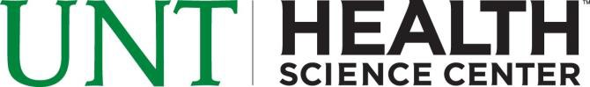Return this completed form to: UNT Health Science Center Office of the Registrar, SSC 244
3500 Camp Bowie Blvd. Fort Worth, TX 76107-2644
FAX: (817) 735-0448 OR Email: Health@unthsc.edu
Bacterial Meningitis Immunization Record
Notice: THIS FORM IS DUE TEN (10) DAYS PRIOR TO THE FIRST DAY OF CLASS
Purpose of this form: This form may be used by any student under the age of 22 entering the UNT Health Science Center in order to satisfy the requirement to submit evidence of a bacterial meningitis vaccination, in compliance with Texas Senate Bill 1107.

STUDENT INFORMATION
UNTHSC Student ID # |  | Enrollment Term (Check One) Year  Fall Summer: 3 Week/5 Week 1/10 Week  Spring Summer: 5 Week 2
Last Name |  | First Name | Middle Initial
Mailing Address |  | Apart | ment # Daytime Phone #
City |  | State | Zip Code
Date of Birth  Month Day Year |  | Age Email Addre | ss
SELECT OPTION 1 OR 2
Option 1: Select type of attachment (Documentation must be in English or accompanied by a notarized translation)
Official copy of immunization record stating the type of vaccine administered and signed by a Health Care Provider Medical Exemption affidavit or certificate
Texas Department of State Health Service Exemption for Reasons of Conscience form Official immunization records generated by a state or local health authority
Official immunization record received from school official, including a record from another state
Option 2: To be completed by a Health Care Provider - USE BLACK INK
Date of Immunization

Month Day Year
Official Stamp: Health Care Provider's Name, Address, and Phone Number
Signature and Title of Health Care Provider
Date

Month Day Year
I have read and understand the Bacterial Meningitis immunization requirements. I certify that, to the best of my knowledge, the above information (including attached copies) is true and correct.
Student's Signature - USE BLACK INK ONLY

Month Day Year
Office Use Only
Date Received Date Completed
Accepted Denied
Incomplete Completed By

