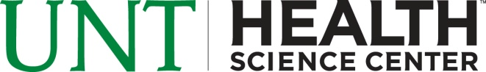
Etta O. Newby Loan Pre-Application
2014-2015 AID YEAR

Student Name:____________________________ Student ID#____________________
I am applying for the Etta O. Newby Loan at UNT Health Science Center and I certify that I meet the requirements below: (Initial Below)
_____I am a Texas native and Resident (Born and Raised in Texas)
_____I graduated from a Texas high school
_____I have requested all Federal Stafford loans I am eligible for this year
_____I am meeting the university’s Satisfactory Academic Progress minimum standard

Student Signature___________________________ Date_______________

