Instructions for Accepting Financial Aid Online

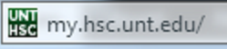

This is the web address to access the student portal.

- First sign into your student portal (MyHSC).

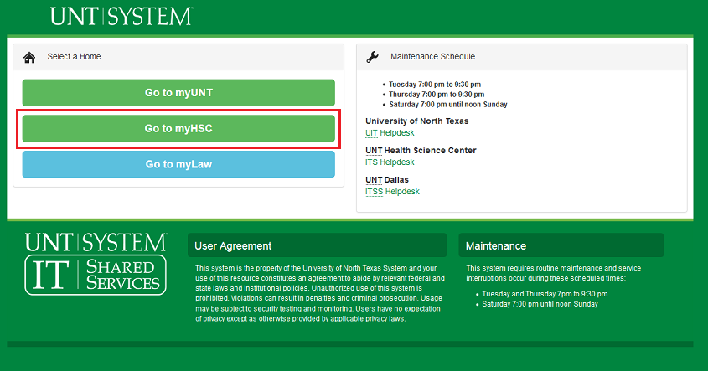
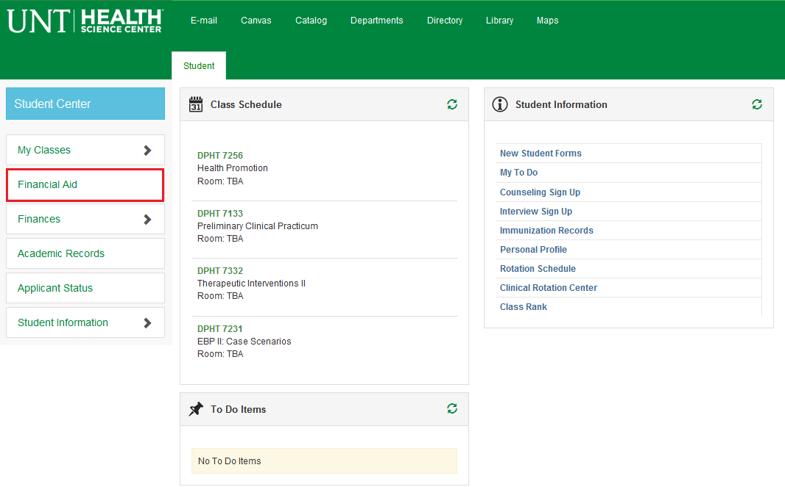
2. Click on the FINANCIAL AID link.

4. Select the 2015 Aid Year link.

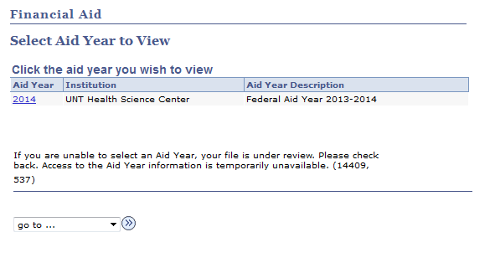

3. Click on MY AWARD INFORMATION link

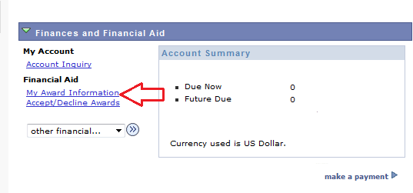
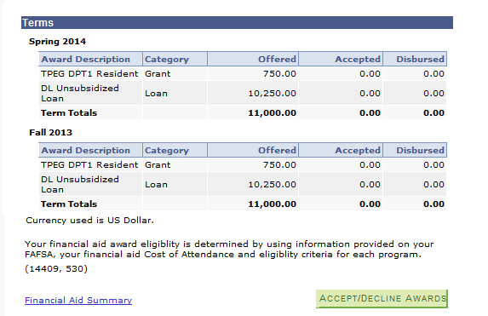
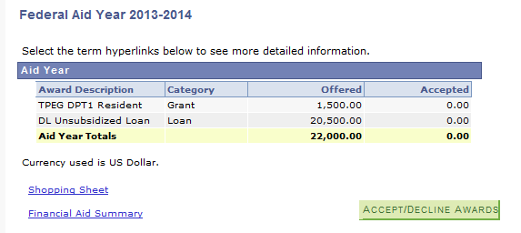
5. The top of the page shows you the yearly total of each award.
6. The bottom of the page shows you how the aid is split up for the school year. Select the ACCEPT/DECLINE AWARDS button to continue.
7. Click the boxes to ACCEPT or DECLINE your aid (a checkmark will appear in the boxes).
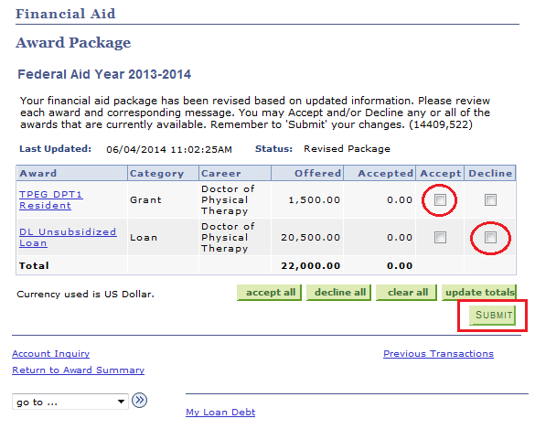
9. Once you click submit you will receive the following message (only if you accepted a loan).
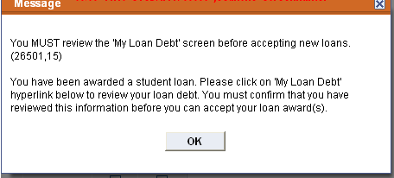
These aid amounts are for the entire year and will split evenly among the semesters.
8. Once you choose Accept/Decline for each award, click SUBMIT. (IF YOU WANT TO REDUCE THE AMOUNT OF A LOAN PLEASE GO TO STEP 12).

11. The following screen will appear. It gives you a snapshot of your educational loan debt. Read all of the information. Once you are done click CONFIRM at the bottom of the page. This takes you back to the award screen. Click SUBMIT (as you did previously) and proceed to step 13.

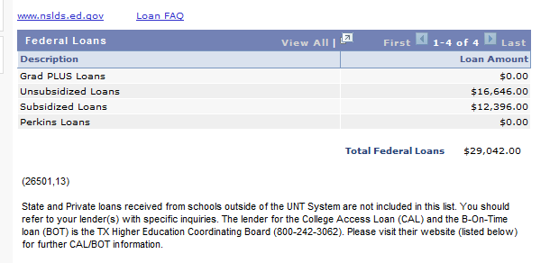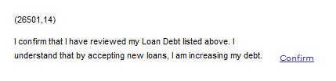
10. Click OK to go through message and then choose MY LOAN DEBT at the bottom of the award screen.
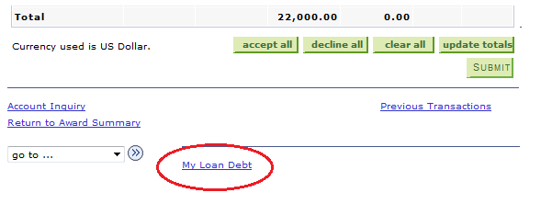
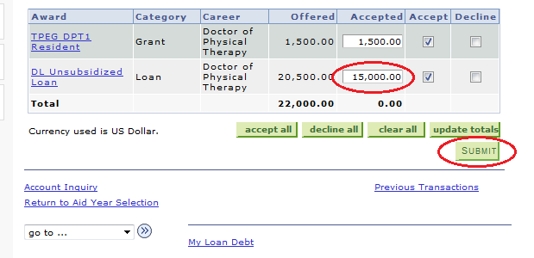
12. If you want to accept an aid offer, but reduce the amount of a certain type of aid, click the ACCEPT box, which will open a place under the Accepted column. In that box you list the amount you do want to accept for this school year. Then click Submit.

REDUCING AID
9. If you want to accept an aid offer but reduce the amount of a certain type of aid, you click the ACCEPT box, which will open a place under the ACCEPTED column. In that box you list the amount you do want to accept for this school year. Then click SUBMIT.
REDUCING AID
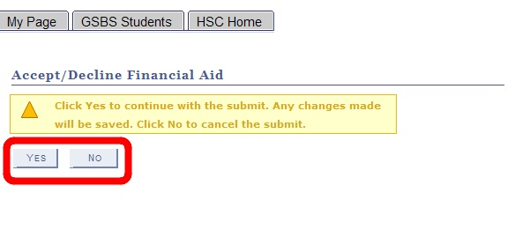
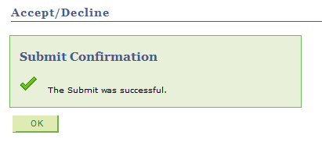
13. You will need to select YES to complete the process or NO to go back and edit.
14. Last step: You must receive the confirmation page or your selections were not submitted.

