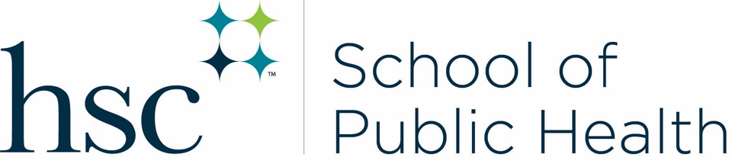
Office of Academic Services
EAD-716
Phone: 817.735.0489
sphacademics@unthsc.edu

Non-Degree Seeking Student

Students who wish to take a course in the HSC School of Public Health should complete this form. This must be submitted prior to the deadlines listed below. All information on this form is required; missing information will result in an incomplete application and will not be reviewed. Students must be in good academic standing (GPA 2.8 or above) in order to be considered. Once complete, this form should be submitted to the Office of Academic Services via email at sphacademics@unthsc.edu.

Last Name First Name

Today’s Date Student ID

Student Email Phone

Course Enrollment Request

Student’s Signature: ___________________________________ Date: __________________

