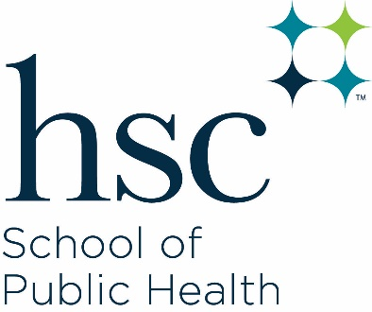

**Office of Academic Services**

EAD 716

Phone: 817-735-0489

[academicssph@unthsc.edu](mailto:academicssph@unthsc.edu)

Dissertation Committee Form

This form must be submitted prior to beginning any work on the dissertation. The Faculty Advisor is responsible for obtaining the signatures of individual committee members and will returned the signed form to the Office of Academic Services via email at sphacademics@unthsc.edu.

Name: Click or tap here to enter text.Student ID: Click or tap here to enter text.

Traditional Dissertation  Three Paper Dissertation

Student must have a minimum of three faculty members: Faculty Advisor, one full-time faculty member with strong expertise in quantitative or qualitative methods; and an additional committee member. If appropriate, students may have as many as five members on their dissertation committee.

Agreement to Serve on the Dissertation Committee:

