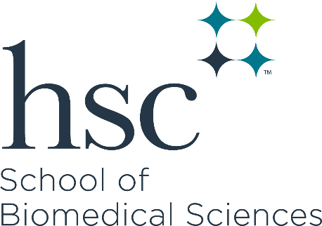 | Traditional Master of Science Program Competencies

Biomedical Scientific Knowledge
- Demonstrates advanced knowledge of biomedical sciences concepts.
- Demonstrates advanced knowledge of discipline-specific concepts.
- Critically evaluates biomedical sciences literature.

Research and Analytic Skills
- Develops testable hypotheses.
- Selects and utilizes appropriate technical and conceptual approaches to design experiments.
- Uses scientific rigor and reproducibility to ensure accurate data analysis and interpretation.

Communication Skills
- Demonstrates effective written communication.
- Demonstrates effective oral communication.
- Demonstrates effective teaching and mentoring.

Professionalism, Collegiality and Career Development
- Demonstrates ethical behavior in alignment with professional codes of conduct, including institutional compliance.
- Establishes rapport with others that encourages a team-based, goal-oriented environment.
- Engages in independent learning and networking.

