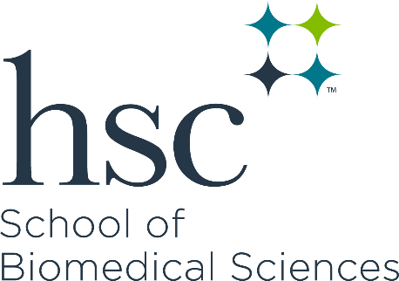

SBS Dean's Fellowship Recognition Award Application Form

The School of Biomedical Sciences offers currently enrolled graduate students a one-time incentive when they successfully compete for a nationally competitive fellowship. The Dean's Fellowship Recognition Program provides a $1,000 incentive for students who receive a nationally competitive fellowship proposal.

If you have questions about the program, contact: paula.gregory@unthsc.edu

Date (mm/dd/yyyy):

Student's Name:

Student's Email & ID:

Mentor's Name & Primary Department:

Title of Project/Fellowship Application:

Funding Agency:

Type of Fellowship: (NRSA, F30, etc.): _

Fellowship Funded Dates: From: _ To:

Please create a single PDF that includes all of the following:

- Completed application form
- Letter from the Mentor verifying that the fellowship application was reviewed and is competitive - Cosigned by the Department Chairman.
- Documentation that the amount of the fellowship is greater than half of student’s current base stipend and tuition/fees.
- Verification of Review by Associate Dean of Faculty & Education Development.
- Verification of receipt of application from funding agency

Email this application to:
Dr. Gregory, Associate Dean for Faculty & Educational Development paula.gregory@unthsc.edu

