Ideate Use Tutorial

Logging In________________________________________________
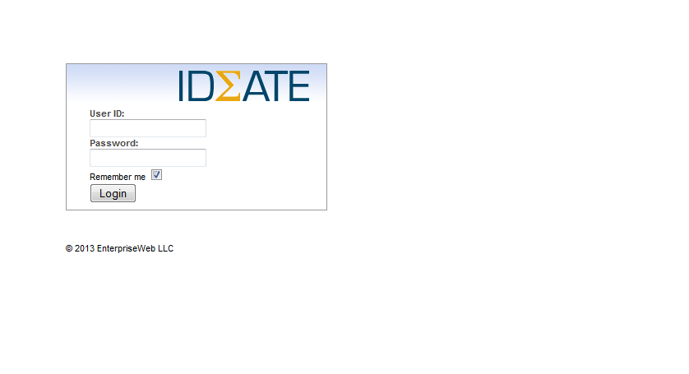
Navigate on your web browser* to ideate.unthsc.edu
Type in your username (EUID)
Type in your password
Click Login

*we recommend that you use Firefox for the web browser

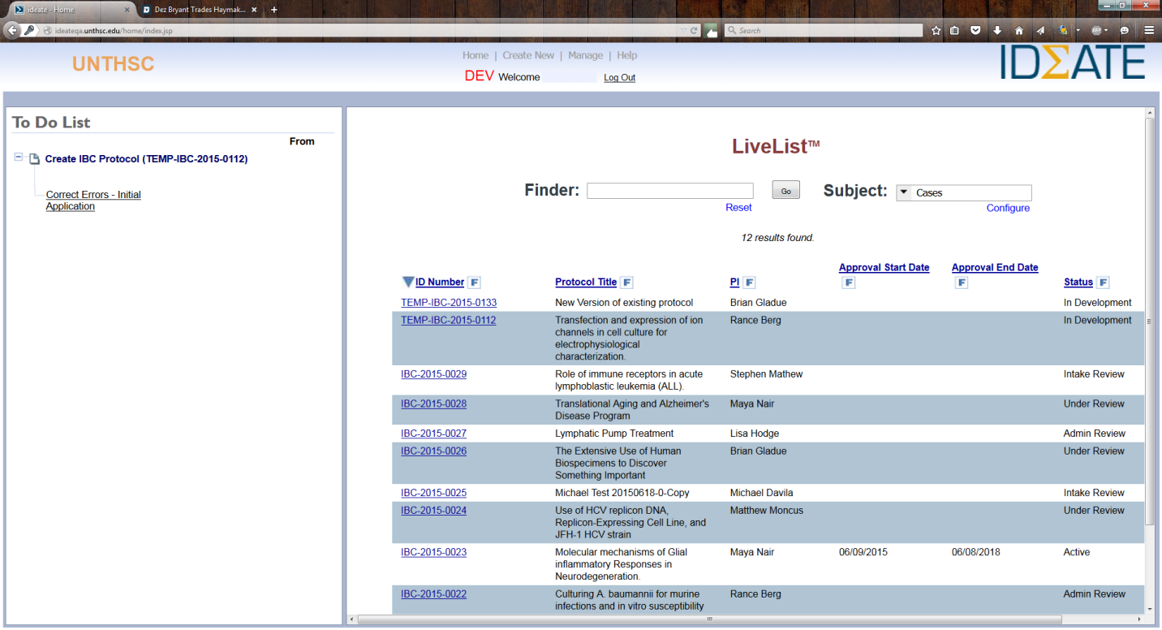
Getting Started_____________________________________________

Pictured above is the starting page in Ideate.
All tasks/action items to be completed will be listed on the left pane highlighted by the green box.
Searching and managing protocols submitted by you will be done using the LiveList highlighted by the red box. The LiveList shows useful information about your applications/protocols created in Ideate.
To monitor the status of approval for your applications/protocols use the “Status” column in the LiveList. It will show what stage of approval your application is in. It is highlighted by the orange box.

Filling Out Your Profile______________________________________
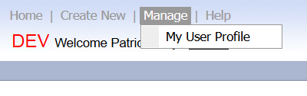

Before starting an application/protocol you must view and complete your user profile by clicking the “Manage” link at the center top of the page and selecting “My User Profile”
You will need to upload your most current CV to your profile page. If you have not not uploaded a CV, you will not be able to attach on while you are completing your IBC/IACUC/IRB protocol.
NOTE: Please complete your profile to the best of your ability and update as needed, as it is used for all modules (IACUC/BioSafteyt/IRB/Grants) within the Ideate Software

Creating an Application/Protocol____________________________
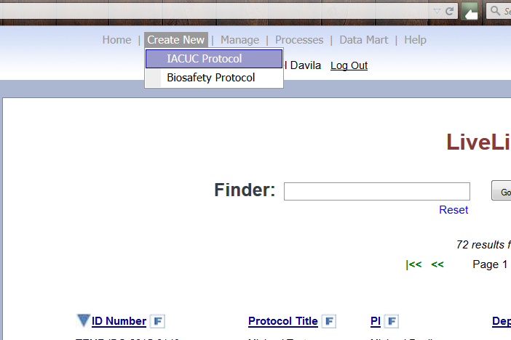

To begin an IACUC or IBC Protocol Application
Click on the “Create New” hyperlink at the top of the page
Then select either “IACUC Protocol” or “Biosafety Protocol” to begin your application.
You are now ready to create your protocol. Simply answer the questions as they appear. You should complete all contents for each tab before moving to the next tab.
Navigate through screens/tabs by using the “next” bottom at the bottom of each screen.
Be sure to save your protocol frequently.
  - After you have a application/protocol submitted, you are able to copy any application/protocol to use as a base for a new application/protocol.
  - To copy an existing application/protocol simply choose “copy from existing” and either type in or choose a previsously submitted protocol. Type in a new title and proceed with your new application/protocol.

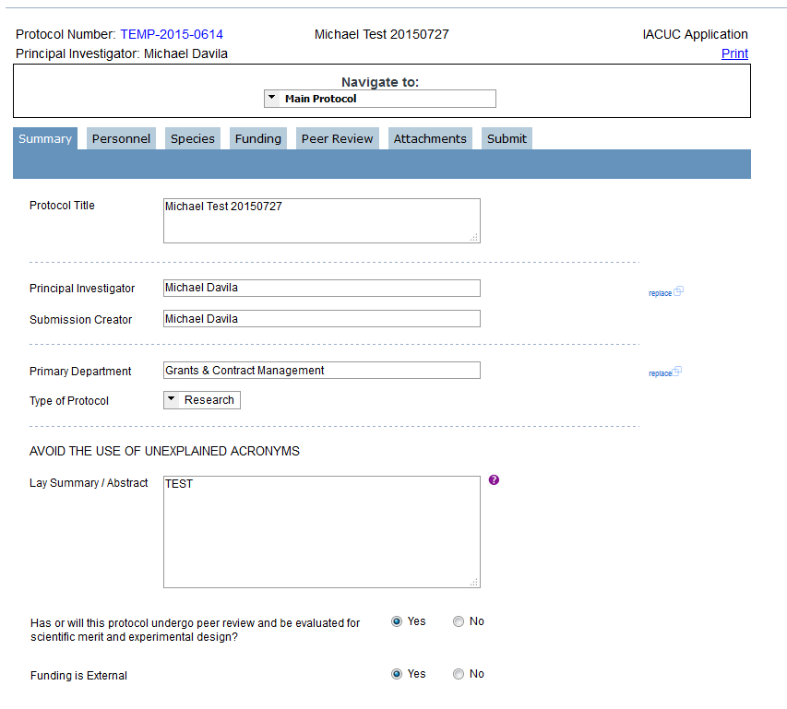
Filling out an Application/Protocol__________________________

The application forms change based on selected answers to certain questions. For example, the Peer Review Tab at the top appeared after selecting “Yes” to the question in the red box. Because of the dynamic forms, you may or may not see a question shown in previous applications.
All questions must be answered in the Ideate application forms. A good rule of thumb is “If you see a question, answer it.”
NOTE: It is necessary to navigate to other forms such as forms for each animal model described in the application within an IACUC application by selecting them in the dropdown box highlighted by the green box above.
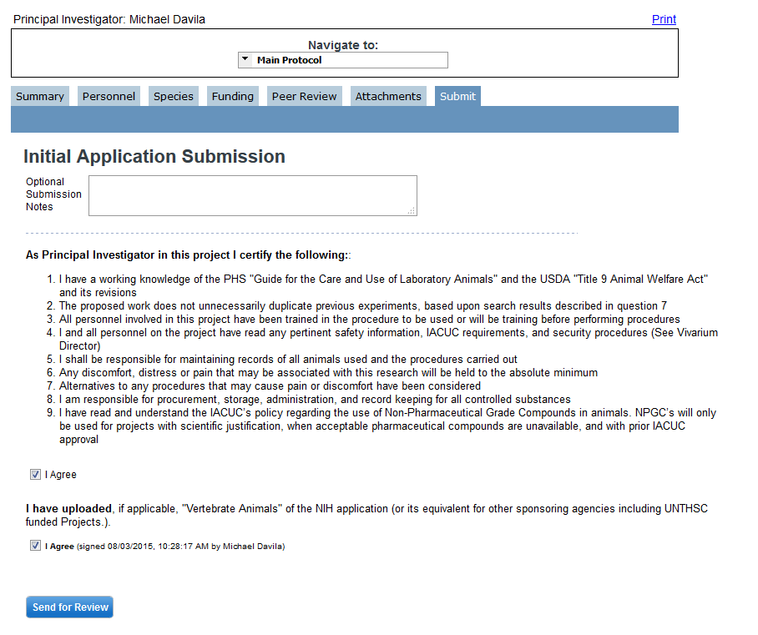
Submitting an Application____________________________________

Submit the application by filling out the “Submit” tab and clicking on the “Send for Review” button.
NOTE: Prior to submission, it is advisable to print the application by clicking the “Print” hyperlink at the top for easy sharing. Printing the application creates a PDF in the browser which can be saved to your computer.

Correcting Errors___________________________________________

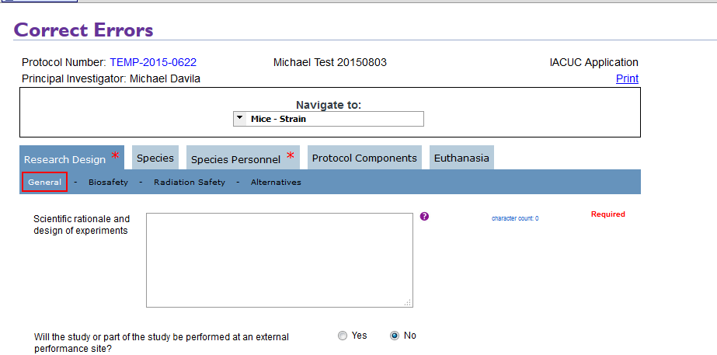
After submitting the application, it is checked by the system for completeness. If there are fields left unanswered, the system will notify you by directing your browser to the page illustrated above.
Tabs and sub-tabs with missing input will be highlighted with red asterisks and red boxes, respectively.
Find and complete the missing information and resubmit via the “Submit” tab.

The Approval Process_______________________________________
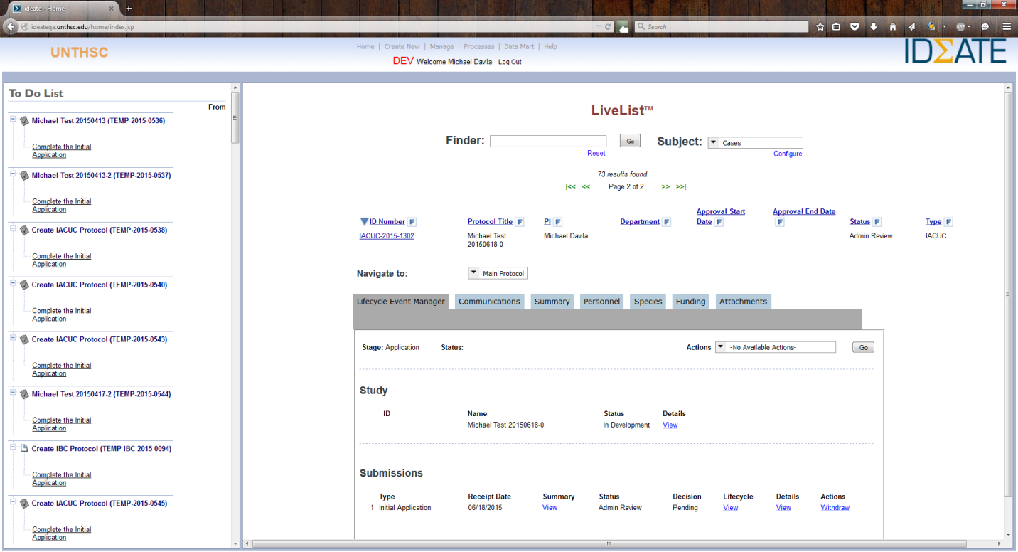
After submitting an application, its status can be monitored via the LiveList. Simply search and click on the protocol ID number and a representation of the protocol will appear.
From this representation of your protocol you can print it to PDF, monitor its approval status, and withdraw.

Questions regarding the software and using the software should be directed to IdeateSupport@unthsc.edu. Questions regarding the content or application/protocol design should be directed to the IBC/IACUC/IRB coordinator.

