Office of Strategic Research Initiatives
UNT Health Science Center at Fort Worth
Junior Faculty Seed Grant Recipients
2011-2012
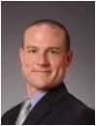
Michael Conners, PT, DPT
Assistant Professor
Department of Physical Therapy
School of Health Professions
Stiffness Evaluation of Shoulder Disability

Rebecca Cunningham, Ph.D.
Research Assistant Professor
Department of Pharmacology & Neuroscience
Graduate School of Biomedical Sciences
Androgens and Caspase-1: Role in Dopaminergic Neurodegeneration

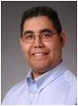

Eric B. Gonzales, Ph.D.
Assistant Professor
Department of Pharmacology & Neuroscience
Graduate School of Biomedical Sciences
Structure Determination of a Male Contraceptive Target

Heather Kitzman-Ulrich, Ph.D.
Assistant Professor
Department of Family Medicine
Texas College of Osteopathic Medicine
A Motivational and Family-Based Weight Management Program for African
American Adolescents

Fernando Wilson, Ph.D.
Assistant Professor Department of Health Management and Policy
School of Public Health
Adversity in Health Care: The Role of Race and Ethnicity in Vehicle Crashes

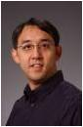
Joseph Yuan, Ph.D.
Assistant Professor
Department of Integrative Physiology
Graduate School of Biomedical Sciences
Gating Mechanism of TRPC’s and Their Role in Cardiac Hypertrophy

