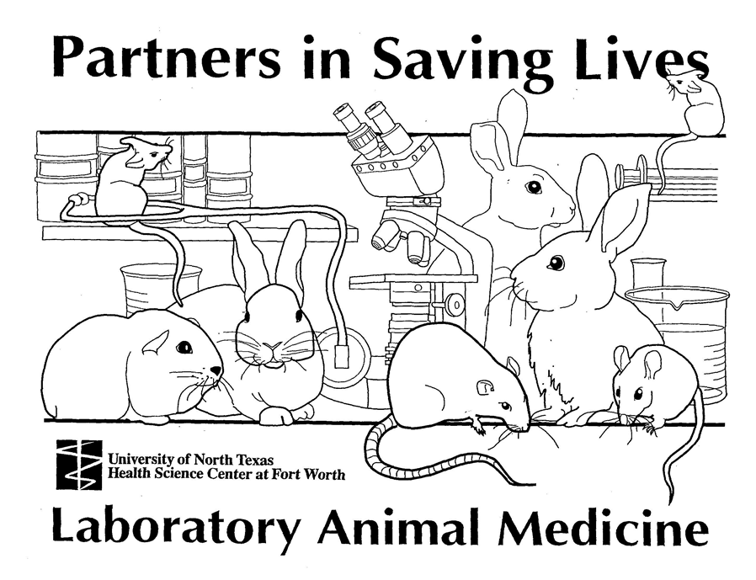
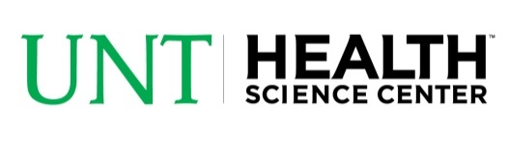
Laboratory Animal Medicine

Policy Manual

UNTHSC IACUC MISSION STATEMENT

The University of North Texas Health Science Center Institutional Animal Care and Use Committee is a research oversight committee charged with the responsibility of ensuring the proper care and use of animals in research, testing, and education. The IACUC also provides assistance to investigators in fulfilling their obligation to plan and conduct animal experiments in accord with the highest scientific, humane, and ethical principles.

INTRODUCTION

In today’s society much controversy exists concerning the use of animals in research. In the past 10 years, public opinion polls have shown a remarkable decline in the number of Americans who strongly support animal research. In the mid-1980’s, more than 70% of the adult population showed strong support for humane animal research; recent polls have shown erosion to less than 55%. Polls of our nation’s young people show less than 33% believe that animal research is necessary or humane. Even those who support research have a poor understanding of how research is conducted and most still express concern that regulations governing the use of animals are not stringent enough.

The Animal Welfare Act (AWA) was first passed in 1966 to address the concerns of the American public regarding the acquisition and use of animals in research. To ensure adherence to the Act, the Congress established a self-oversight mechanism for all research institutions; this oversight is through the Institutional Animal Care and Use Committee (IACUC). The 1985 Amendments to the AWA and concurrent changes in the Public Health Service Policy of Use of Animals by Awardee Institutions (PHS Policy) increased the oversight responsibilities of the IACUC. Today, every institution conducting animal-based research, teaching or testing, must establish an IACUC to oversee the institution’s animal care and use program. The IACUC’s membership and responsibilities are mandated and defined by federal law and carried out through local policy.

The UNTHSC’s Animal Care and Use Program encompasses all animals used by UNTHSC for research, testing, education, or any other purpose. In addition to the IACUC, the Program is composed of community (non-affiliated) and members of the UNTHSC community who use animals. Often research investigators view the IACUC and Department of Laboratory Animal Medicine (DLAM) as synonymous; each is autonomous. The DLAM is under the purview of the Committee in much the same way as researchers are. It is Veterinarians’ responsibility to carry out the Program for the IACUC and DLAM, providing support to the research and teaching programs of the UNTHSC through acquisition and care of animals used by the UNTHSC community. In simple terms, the IACUC is the regulatory arm of the program and the DLAM is the administrative.

The use of animals in research and teaching is a privilege carrying with it unique professional and moral obligations to ensure that animals are treated humanely and in accordance with the policies of the UNTHSC, the regulations of the Animal Welfare Act, and other laws and policies of the federal government and other agencies. The ultimate responsibility for compliance with regulations that affect the care and use of animals lies with the animal users themselves; thus, it is of paramount importance that each of you has knowledge of the regulatory requirements and local policies. Every person using animals, whether investigator, technician, student, or instructor, must be aware of and abide by their attendant obligations to assure that animals utilized by the University’s programs are used in a humane manner.

It is also necessary for all who perform animal research, teaching, or testing, to ensure that animals are utilized only if the information gained promises to contribute to understanding of fundamental biological principles or to the development of knowledge that can be expected to benefit humans or animals. The tenets of the “3Rs” approach to animal research, “Replacement, Reduction, and Refinement” should be followed at all times. Animals should be used only when the researcher’s best efforts to find an alternative model have failed. When there is no acceptable alternative, researchers should employ the most humane methods, using the smallest number of appropriate animals necessary to obtain statistically valid results. Only when research is performed appropriately and humanely can there be assurance of the continued use of animal models in the quest for knowledge.

LAB ANIMAL FACILITY POLICIES

Welcome to the Department of Laboratory Animal Medicine

University of North Texas Health Science Center

Access to the facility:

Keys and access cards are only granted upon successful completion of the following:

Online training: Care and Humane Use of Animals and species specific modules.

Review of facility policies.

Attend Hands-on training.

Complete a Medical History Questionnaire.

Personnel have been added to the protocol by the PI.

Completed key and access card request form. (Keys and Access cards are distributed by Campus Police) The key request form must be signed by your supervisor and then submitted to the Department of Lab Animal Medicine for approval before your key request can be processed. NOTE: DLAM is the only department that can grant vivarium access.

Laboratory Apparel

To enter the lab animal facility you must be dressed accordingly. The following attire is required for safety and security reasons:

Always have your ID badge visible. If you do not have a badge, DLAM personnel cannot allow you access to the facility. Your badge shows proof you can access this secure area.

Always have on a clean lab coat or clean set of scrubs when entering the facility.

Wear solid shoes, preferably rubber-soled shoes (i.e. tennis shoes). No open toed, or open backed shoes. This is for your safety - the main hall of the vivarium has constant traffic of cages, carts and cage racks, also the floors of animal rooms and hallway are mopped frequently to maintain sanitation.

Please avoid wearing heavy colognes or perfume. The scents may upset or change the behavior of the animals. Behavior studies may be on-going.

Smoking: If you are a smoker, it is recommended that you do not wear your lab coat while on your smoke-break. The smoke residue smell left on your clothes can upset or change the behavior of the animals.

Occupational Health & Safety

Do not enter other animal rooms: When working in your animal room, please do not enter other animal rooms. This prevents cross contamination. There are several diseases that are zoonotic between different species of rodents that could result in the death of a colony.

Gloves: Handle all lab animals with gloves - this protects you from animal allergens and protects the animals from potential exposure to disease causing organisms on your hands.

Working with potential Zoonotic species: You must follow any and all guidelines set forth by the Department of Lab Animal Medicine in the proper handling and use of any species that may be potentially zoonotic. This is for your protection as well as the protection of the animals.

Do not enter the “Clean Room”: If you need new tubs, bottles, feed hoppers, etc. look in the blue bio-bubble or ask one of the DLAM staff. This room holds caging for all the animals in the facility; limiting access to this room helps prevent cross contamination.

Clean up after yourself: Please remove needles, syringes, etc. There are trash cans, brooms and dust pans in each room. If you continue to leave your room in disorder, it may result in additional charges to your per diem.

Do Not place cages on the floor: This is a hazard and should never be done.

Sharps containers: Be sure to place all sharps (needles, scalpel blades, etc.) into a sharps container before exiting the room. Leaving sharps in the rooms endangers other laboratory workers as well as DLAM personnel. Please bring a sharps container (DLAM can supply you with one) into the room if you need one. The procedure rooms, (28, 97 and 106) are equipped with sharps containers.

Bites and Scratches: If you get bit or scratched by an animal in the animal facility, wash the area with soap and water and report the incident to your supervisor.

Allergies: This is the most common health problem associated with lab animals. Wearing proper PPE (mask, gloves, lab coat) will help prevent symptoms. If you develop allergies at any time while working with the animals, please notify your supervisor.

Radios, Headphones, Cell phones or Cameras are PROHIBITED in the Animal Facility.

Fire Alarms: When the fire alarm sounds, please cease your work and exit out the door leading to the docks until the all-clear is sounded.

Pay attention to warning labels and signs: Please pay attention to signs and labels on doorways, rooms, bottles, etc. They are there for your protection as well as the animals in the vivarium.

Animal Health & Husbandry

Animal Health/Sick animals: The health of each animal in the facility is assessed daily. If you notice your animals have become ill (not eating, drinking, weight loss, etc.), notify DLAM personnel immediately. Place an orange, “Med Case” card (found on the supply cart in the hallway) on the cage so our Animal Health Technician can find the animal to make a health assessment.

Dead animals: If you find one of your animals dead in your room notify DLAM personnel. Place the dead animal in a glove (small animals) or a black bag (large animals) and take it to one of the DLAM personnel for proper disposal. If DLAM personnel find one of your animals dead, the investigator will be notified.

Assessing Animal Health: Things to look for when assessing rodent health include:

Activity level - lethargic

Behavior – vocalizing, self-trauma, aggressive

Food/Fluid intake – decreased feces/urine

Eyes – red staining

Fur – unkempt, soiled fur

Posture – hunched

Respiratory – opening mouth, labored breathing

Others – seizures, tremors, tumors, infection of wounds, paralysis

These are signs that the animal may be in pain. Notify the Animal Health Technician of any of these conditions.

Cage Changes/Room cleaning schedule: All animal rooms and caging are changed/cleaned a minimum of every 14 days. Some rooms require weekly or even daily changes. The schedule for your animals cage change is posted on the room door. If you have any concerns or questions with the schedule of your room maintenance, contact Facility Manager at x2013.

Feeding: DLAM personnel will free feed (Ad Libitum) a pelleted lab animal diet to all rodents, rabbits, mice, guinea pigs unless animals are on restricted diet. If you have any questions concerning the feeding of your animals, please contact Facility Manager x2013.

Cage cards: Please do not remove cage cards or write on them outside of the “Notes” section. These identify the animal, species/strain, principal investigator and the protocol. Extra cards for your notes and information can be placed behind the cage card in the cage card holder. We provide various pre-printed cards for your use such as breeder cards and treatment cards. Ask DLAM personnel if you need one of these cards. If you separate animals, please ask fill out a Cage Card Request or email dlam@unthsc.edu for more cage cards – all animals must have a cage card at all times.

Animal Transfers: When animals need to be transferred to a different protocol or investigator, an Animal Transfer form (found on the IACUC and the DLAM website), must be filled out, signed by the investigator, and turned in to the DLAM inboxes, which can be found in each hallway, or emailed to dlam@unthsc.edu. These transfer forms help keep track of your animal numbers on each protocol. DLAM staff will then print new cage cards for the transferred animals reflecting the correct protocol number.

Animal density requirements: DLAM adheres to the standards set forth in the Guide for the Care and Use of Laboratory Animals. A table listing the recommended space allocations for laboratory animals can be found in The Guide. Many cage options are available and the number of animals allowed per cage is dependent on many factors and study considerations. For specific questions regarding the housing of the animals on your protocol, please contact Facility Manager x2013.

Movement of animals in cages in the animal room: If you need to separate animals at any time, the animal(s) being moved must have a cage card (see cage card section above). Please make sure the new cage has food and water. If you pair animals for mating, please add a “Litter Watch” card on the cage. Male animals should never be housed together after they have been separated, especially after mating – they will fight.

Sentinels: There are sentinel animals in each of the animal rooms. They are indicated by bright blue cage cards. These animals are placed in each room by DLAM for monitoring the health status of each room. Please do not handle these animals or use them. These animals or their blood is sent off every 3 months to test for pathogens.

Dirty or soiled caging: If you have dirty caging in your lab, or empty tubs in your animal room, please place them in the shelves with the red covers. If you find a flooded tub please notify DLAM personnel.

Using pups: If you are breeding rodents on your protocol, all pups must be counted. Please keep a record of pups and turn these in to the DLAM inboxes or email them to dlam@unthsc.edu monthly.

Breeding: Breeding records must be turned in to DLAM on a monthly basis.

Euthanasia

Method of euthanasia: Animals can only be sacrificed by the approved methods outlined by the American Veterinary Medical Association and in your protocol. Any deviation from this can result in the loss of facility privileges or protocol. Always follow your protocol.

Policies for Euthanasia:

If you need animals sacrificed, please complete an Animal Euthanasia Form (green sheet); also mark the cage card of the animal to be sacrificed with an “X.” These can be found on the shelves at the west entrance to the facility or ask the DLAM staff for one.

If you have sacrificed animals in your lab they should be placed in a black bag and given to DLAM personnel for proper disposal. Please call x2014 to request one of the DLAM staff to meet you at the carcass freezer on the dock. Please do not use the red biohazard bags for regular disposal; this alerts our staff that there may be a potential contaminant or hazard.

If you have a number of animals to be sacrificed after testing you can complete a Euthanasia form if you want DLAM staff to euthanize them for you. The DLAM staff member will then perform the euthanasia procedure. At no time are the animals to be left unattended. If you wish to do the euthanasia, DLAM staff will need to meet you at the door to Necropsy to unlock the door.

See the Anesthesia, Analgesia and Euthanasia hand-out for more information on euthanizing animals. The Principal Investigator will show lab members how to properly euthanize according to the approved protocol.

Performing Procedures on Animals

Training: The Principle Investigator (or other lab staff) is responsible for showing lab staff how to properly do all procedures that are approved on the protocol.

Reminders:

Always follow the protocol

Ask questions when in doubt, seek assistance

Anesthesia

Anesthesia may be used for procedures other than surgery.

If an animal is anesthetized, a Surgery/Post-op Record must be completed and turned in to the Animal Health Technician (see Anesthesia, Analgesia, Euthanasia hand-out).

If you use Isoflurane, the animals will wake up quickly. If you use an injectable, the animals take longer to wake and they must be kept warm and someone must stay with them until they are awake.

Transporting Animals

Transportation carts/cages: Animals must be transported in cages with a secure wire cage-top, microisolator top, and Tyvek cover for each individual cage (rodents), or transportation cages and covered with a Tyvek cover (provided by DLAM) to reduce stress and exposure of animal allergens to non-animal workers. DLAM provides carts for investigator use only in the DLAM facility. Do not remove these carts from the animal facility for any reason. Your lab must provide carts for transport to and from your lab. DLAM provides the Tyvek covers for the cages and carts. For sanitary reasons, please assure that the animals are in a clean cage before transporting.

Animals to and from the lab: Only animals that are housed in the conventional hall (blue hall) can be moved to and from the lab freely. Animals that are housed in the barrier hall (requires additional access) cannot be moved to and from the lab. Once the animals are removed, they cannot be returned.

Transport of Live animals to and from the CBH building can only be done by DLAM staff. You will need to send an animal transfer form to dlam@unthsc.edu to request transport. You must give 24 hours notice for these transports.

Housing animals outside the vivarium: Animals cannot be housed in your lab over-night (24hrs) unless it is approved in the research protocol. Animals found to be in your lab without authorization can result in loss of facility access privileges or protocol suspension. If animals are to be housed overnight in your lab they must have access to food and water, and be housed properly, adhering to cage space/animal number requirements. If animals will be housed for 12 hours in your lab, notify a member of DLAM so our staff can verify the animal’s health and provide feed and/or water, if necessary.

Freight elevator: The freight elevator is for the use of transporting animals and biological materials. The passenger elevator is only to be used in the event the freight elevator is out of service. Unauthorized use of the passenger elevator can result in the loss of facility access or protocol suspension.

Working with animals outside the vivarium

It is important to follow the same policies and procedures when you are working with your animals in your lab outside the vivarium, i.e. clean lab coat, gloves, mask.

The same policies and procedures for the handling and use of your animals also apply when you are working with your animals in your lab outside the vivarium.

Keep your lab clean: No food or drink is allowed in your lab.

Keep your lab locked at all times, especially when animals are present in the room.

No animals should be left unattended.

If you have animals recovering in your lab it is recommended that you cover the cage with a drape in case non-animal workers such as facilities personnel enter the lab to make a repair or check environmental controls.

A cleaning log must be kept in the lab to maintain a record when the lab and equipment the animals come in contact with was last sanitized.

Training

Procedures specific to your protocol will be taught to you by your lab.

Surgery training is mandatory if you will be performing surgery. There is a surgical presentation. Please contact Tito Nelson (x0590) for more information and for scheduling.

DLAM has training available, if needed, to train you in handling, surgical, blood and tissue collection techniques, and euthanasia. Contact Tito Nelson for more information and scheduling.

Facility Security

Have your ID badge visible when inside the vivarium.

No unauthorized visitors are allowed in the vivarium, including after hours and weekends, unless approved by the Director of the Department of Lab Animal Medicine or his designee.

Visitors must sign in at the DLAM office, RES-127. Visitors are those individuals who have not had DLAM training.

Do not let others use your badge/keys. Do not allow someone who has not had policy training access to the vivarium without assistance.

Concerns with the Animal Care and Welfare

If you have any concerns or questions dealing with the care, use and or handling of the animals in the vivarium please bring it to the attention to any of the following:

Dr. Daniels

IACUC office

Ethics Line

Others listed on emergency poster in labs and in animal facility

Your name will be kept confidential.

Protocol Reminders

Animals can only be ordered on approved protocols.

You must be listed on the protocol before you do procedures on a protocol.

Read and understand the protocol.

Do not do procedures that are not listed on the protocol.

Do not use drugs that are not listed on the protocol.

If you need to change something on a protocol, contact the IACUC office (Christina Aguilar) to add an amendment. The amendment must be approved before a new procedure can be started.

DLAM Staff

DLAM staff is trained in the care and use of laboratory animals, and can be an important role in your research. Our facility requires that all DLAM staff working with animals become AALAS (American Association for Laboratory Science) certified. This ensures that our staff is skilled and knowledgeable in the many aspects of laboratory animal science environment.
- Lab staff is available Monday – Friday, 7:00 am – 5:00 pm.
- Limited staff is available on weekends, contact Marcie Dorsett by cell phone for immediate assistance.
An emergency contact list is posted in the vivarium entry and hallways. Listed below is our staff and contact numbers:

Egeenee Q. Daniels, DVM

Director and Staff Veterinarian: Oversees the health care of all laboratory animals housed in the vivarium. Enforces PHS Animal Welfare policies. All protocols must be evaluated by the veterinarian before going to the IACUC for approval. Any concerns with the health and welfare of the animals can be directed to him.

Ph: 817-735-2017

E-mail: Egeenee.Daniels@unthsc.edu

Office: RES – 127C

Marcie Dorsett, CMAR, RLATG

Facility Manager: Oversees the facility environment, lab animal attendant supervisor, coordinates facility work schedule, assists/instructs special procedures, coordinator of continuing education of our staff, and fulfills the duties of the director in his absence. If you have any questions concerning the environment, animal care, personnel or maintenance, please contact Facility Manager.

Ph: 817-735-2013

Cell : 817-565-4574

E-mail: Marcie.Dorsett@unthsc.edu

Office: RES -127D

Lacy Bowen, MBA

Operations Analyst: Coordinates front office scheduling and communication, payroll, accounts payable, accounts receivable, etc.

Ph: 817-735-2017

E-mail: lacy.bowen@unthsc.edu

Office: RES– 127

“Tito” Nelson, RVT

Veterinary Technician: Ensures the health of the animals in the DLAM facility. Responsibilities include rodent health monitoring and assessment, ensures rodent health via the sentinel program, pre/post-surgical care of chronic surgery animals, chronic canine & rabbit surgical scheduling, diagnostic testing and radiographs. She trains personnel on large animal handling and surgery techniques. If you have any questions concerning your animal health and welfare, or to schedule large animal or surgery training, contact Tito.

Ph: 817-735-0590

E-mail: Tito.Nelson@unthsc.edu

Office: RES – 128

Attendants/Technicians

Responsible for daily room checks, animal room changes, animal health care monitoring and sanitation. These are the people along with Marcie and Angela that are in your rooms daily. Your room techs can be contacted at 817-735-2014.

Weekend Personnel

The weekend staff member carries a pager in the facility. If you need assistance on the weekends between 8 AM – 2 PM please page 817-216-1180, or contact the Facility Manager via cell phone.

IACUC Staff

Christina Aguilar

IACUC (Institutional Animal Care and Use Committee) Coordinator. Please visit the website: http://www.hsc.unt.edu/IACUC/index.cfm for information regarding IACUC policies, procedures, forms and other information.

Ph: 817-735-2533
E-mail: christina.aguilar@unthsc.edu
Office: CBH 160B
Trainee Copy

Department of Laboratory Animal Medicine at the University of North Texas Health Science Center

Policy Training

Signing this document assures the Department of Laboratory Medicine that you have fully understood the policies regarding the use of animals at the University of North Texas Health Science Center that were just presented to you in presentation form and given to you in a manual. If you are ever unsure about policies or procedures, you will refer back to the manual or will ask a DLAM employee for assistance.

I was present at the University of North Texas Health Science Center’s Department of Laboratory Animal Medicine’s Policy Training on (date) ____________________ and understand my responsibilities on the care and use of animals.

Trainer Copy

Department of Laboratory Animal Medicine at the University of North Texas Health Science Center

Policy Training

Signing this document assures the Department of Laboratory Medicine that you have fully understood the policies regarding the use of animals at the University of North Texas Health Science Center that were just presented to you in presentation form and given to you in a manual. If you are ever unsure about policies or procedures, you will refer back to the manual or will ask a DLAM employee for assistance.

I was present at the University of North Texas Health Science Center’s Department of Laboratory Animal Medicine’s Policy Training on (date) ____________________ and understand my responsibilities on the care and use of animals.

Name of Trainee (please print):___________________________________

Signature:

___________________________________Date:_________________________

Name of Trainer (please print): ____________________________________

Signature:

___________________________________Date:_________________________

