There are 2 versions of a Planning Document. For Clinical Faculty, please use the Clinical Faculty Planning Document. For all other faculty, please use the Offer Planning Document.

These instructions are for non-clinical faculty.

Planning – Left Side

When planning for a new faculty hire begin on the left side of the form (Recruitment Plan). Estimate any funding that will be part of the offer, by funding source.
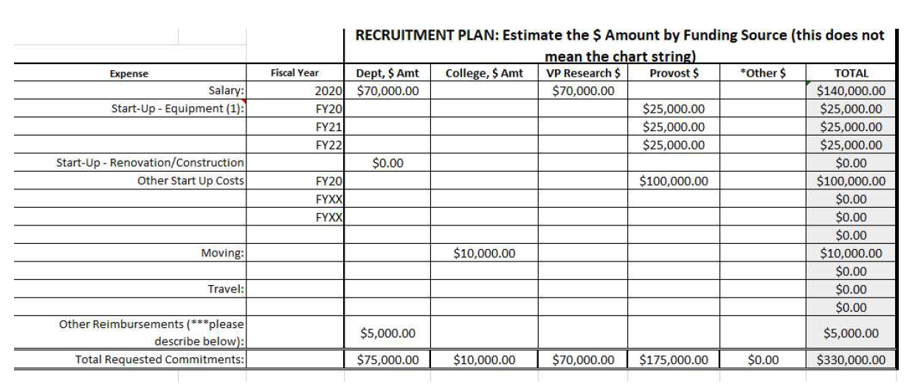Example: Salary split between the Department and the Division of Research, Start-Up package from the Provost and moving allowance from the Dean.

Make sure that the owner of each funding source has agreed to provide the requested funding before moving forward.

Identify any additional sources of funding that are listed in the Other column.
Obtain proposed chart strings for the funding. Please note, chart strings may change before the final
offer.

Obtain signatures (on the left side) for any department that is providing funding. The Department Chair
and Dean must signoff.
The Provost should approve all the paid faculty positions before posting. After the school obtains the required signatures, send the OPD to Faculty Affairs. Faculty Affairs will route it to the Provost to request approval.
Post the position and begin searching for our new faculty member.

Offer – Right Side

When the new faculty member is identified, negotiate the final offer amounts.
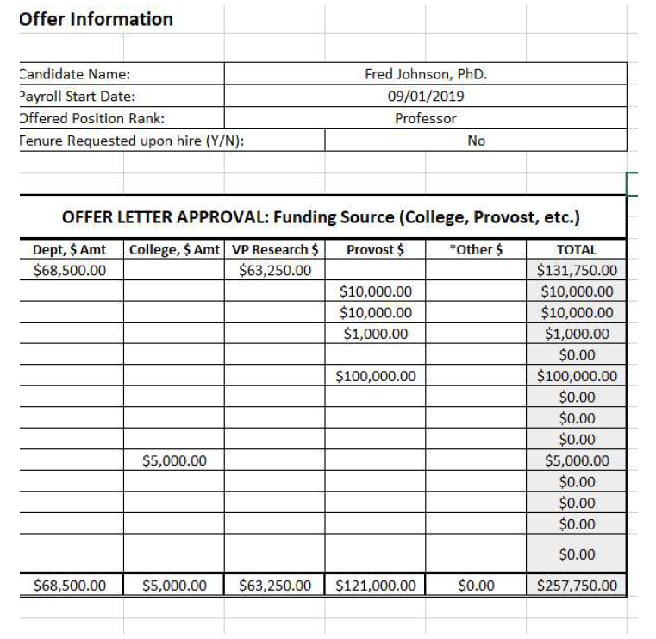Once the final offer amounts are agreed to, fill out the Offer Information (Right Side) of the OPD.
Please complete the Start-Up Detail tab for any candidates that are receiving a Start-Up package greater
than $100k

Verify the chart strings for all funding sources.

Obtain signatures on the right side for any department that is providing funding. Send the form to Faculty Affairs. Faculty Affairs will route it to obtain the Provost’s approval.

Include the fully signed OPD in the hiring ePar.
Instruction on how to edit the OPD after it was signed on the left side:

OPD saved in PDF with the left side completed and signed
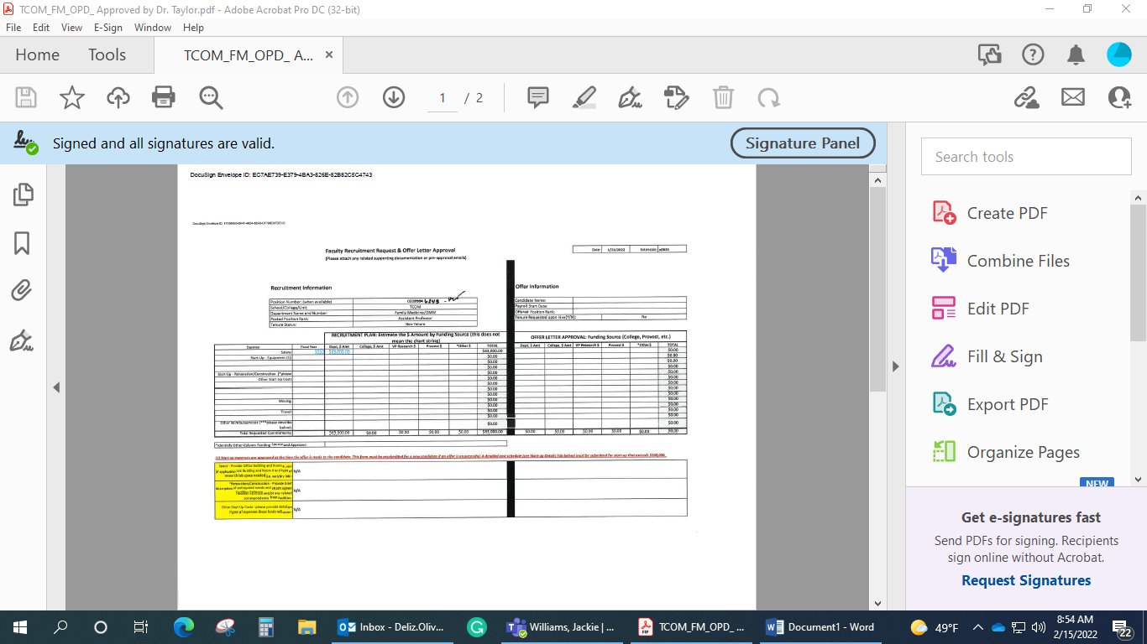

Press File -- Print, and select “Microsoft print to PDF”—Print
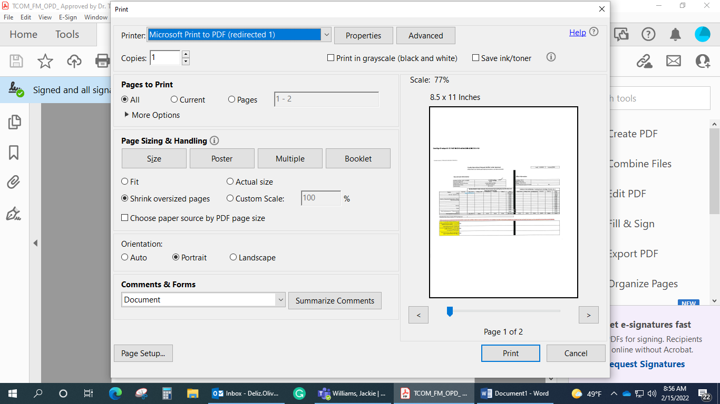

Save the document in your Computer
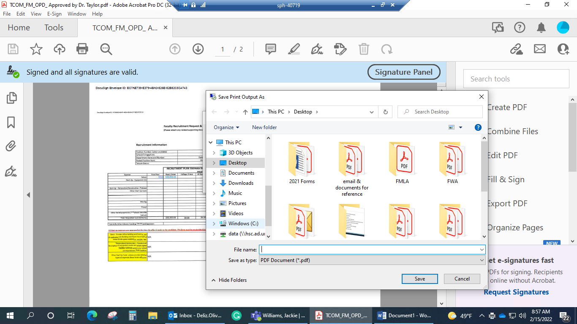

Close the original document and open the new version. Now you can press “Edit PDF.
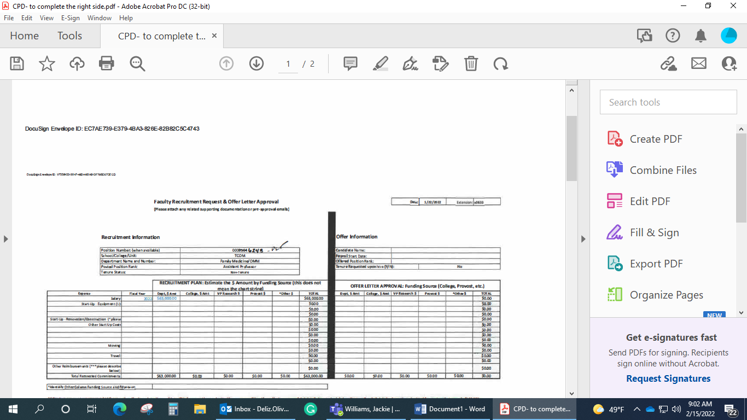

Press “Add Text” and type all the required information on the right side. Because it is not an excel document anymore, you must write all the information. When completed, save it and route it for the right side signatures.
