HSC Student Employment – How to Apply
Step 1 – Navigate to the Applicant Tracking System at https://jobs.untsystem.edu.
Log in or create a new account with your student email address (@my.unthsc.edu).

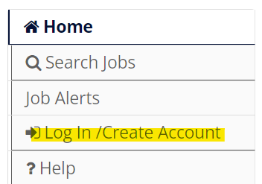
Step 2 – Click on the “Search Internal Jobs” link in the side menu.

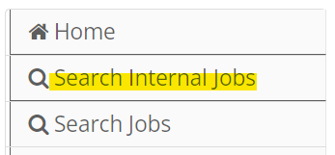
Step 3 – Select “Student” as the Position Type and “Fort Worth” as the Job Location.
Step 4 – Click on the title of the position you are interested in applying to. Read the Position Details. Click on the “Apply for this job” to create/submit your application.
Step 5 – Once all fields are completed, click “Certify and Submit”.
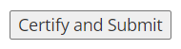
09.2023

