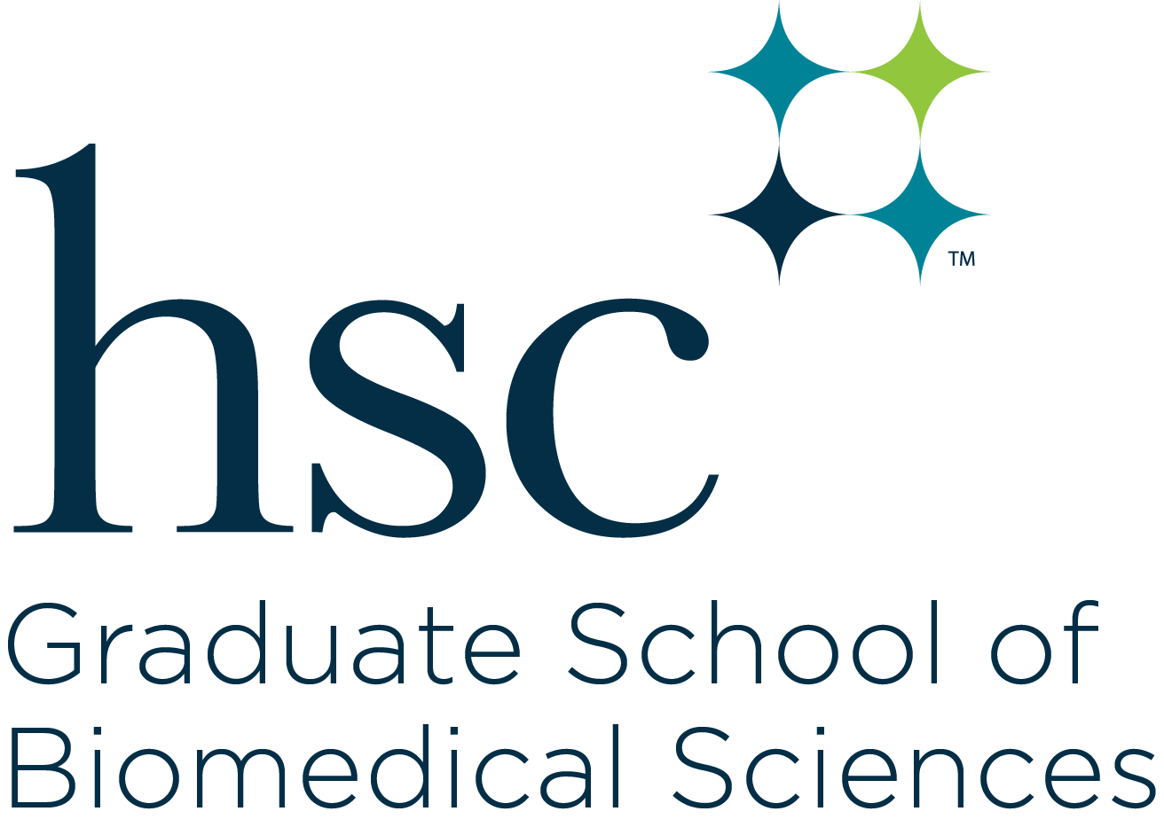

Medical Science
Student Handbook
2021-22

The information provided in this document serves to supplement the requirements of the Graduate School of Biomedical Sciences detailed in the UNTHSC Catalog with requirements specific to the discipline of Clinical Research Management.

Table of Contents

Page

Medical Science Program Description 3

Opportunities for Graduates in Medical Sciences 3

Program Success 3

Program Requirements 4

Medical Science Curriculum/Degree Plan, Classroom-based 4

Medical Science Curriculum/Degree Plan, Online 5

Medical Science 2-Year Research Track Description 5

Transfer to Research Track 6

Medical Science Research Track Curriculum/Degree Plan 7
Description of Internship Practicum 8
Duration and Time of Internship 9
Activities During the Internship 9
Proprietary Studies and Agreements 9
Student Advisory Committee 9
Expectations of Internship Practicum 10
Timetable of Internship Practicum 11
Internship Proposal and Final Practicum Report 12
TurnItIn 13

Lisa Hodge, PhD
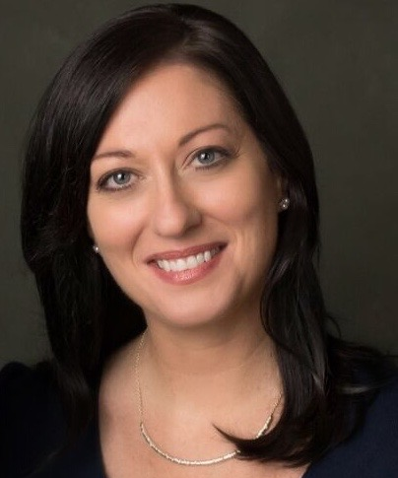
Associate Professor, Department of Physiology and Anatomy
Director of the Assistant Dean for Specialized Masters Programs
Director of the Master of Science in Medical Sciences Program
University of North Te University of North Texas Health Science Center
3500 Camp Bowie Boulevard
Fort Worth Fort Worth, Texas 76107
817-735- (817) 735-2110
` Office: EAD 324-A
Email: lisa.hodge@unthsc.edu

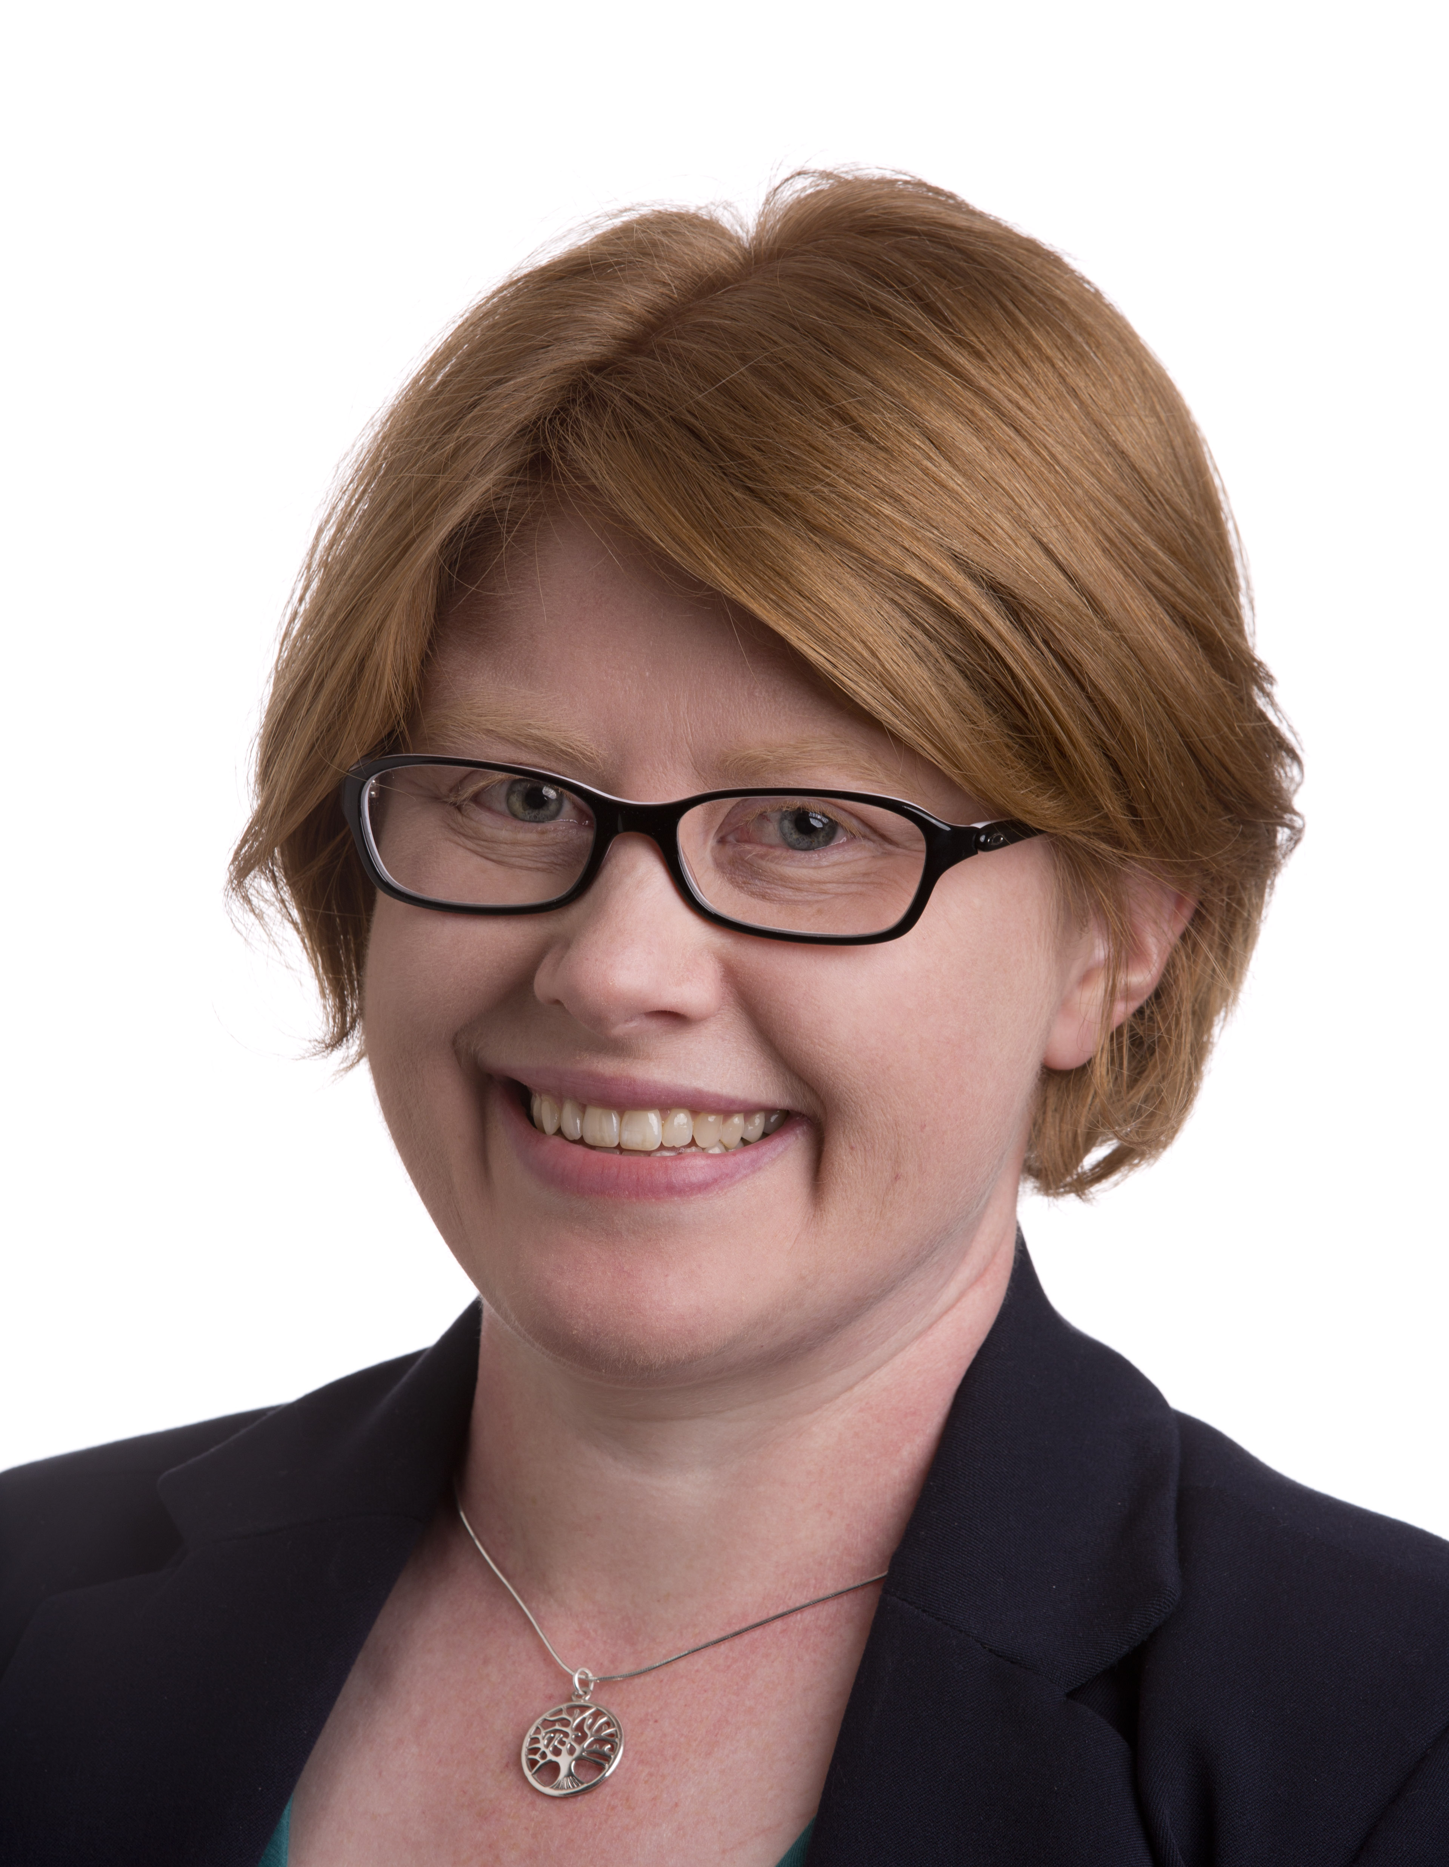
Caroline A. Rickards, PhD
Associate Professor, Department of Physiology and Anatomy
Director, Medical Sciences Research Track
University of North Texas Health Science Center
3500 Camp Bowie Boulevard
Fort Worth, Texas 76107
(817) 735-2735
Office: EAD 310-H
Email: caroline.rickards@unthsc.edu

Program Description
The Master of Science program in Medical Sciences is designed to provide additional educational and training opportunities to individuals who would like to enhance their credentials for entry into medical, dental, or other professional schools. This is achieved by offering a strong, challenging biomedical sciences curriculum in the environment of a health science center.
We recognize that there are bright, highly motivated students whose goal is to become a physician, dentist, or other health professional but an unexpected roadblock prevents their entry into these competitive professional schools. Examples of these roadblocks include non-competitive grade point average, borderline Medical College Admission Test (MCAT), DAT or GRE score, marginal letters of evaluation, or insufficient clinical exposure. The Medical Sciences Program is also designed for those students who want to experience an intensive academic curriculum in a medical school setting before deciding whether medicine is the career for them.

Our graduate-level science program is designed to enhance student’s knowledge and skills before they apply/reapply to professional school. The average time to complete the non-thesis M.S. degree in Medical Sciences is twelve months. Our classroom-based program is offered mid-May through mid-May. Our online program is offered mid-August through mid-August. The classroom-based program only admits students in the summer semester. The online program only admits students in the fall semester.

Opportunities for Graduates in Medical Sciences
The M.S. in Medical Sciences program responds to the need for graduate study in the medical sciences by providing students with the background required for the pursuit of a variety of careers in the health professions. It is a broad-based curriculum that can provide the student with requirements to pursue medical school, dental school, veterinary school, advanced graduate education, or enter a career in allied health sciences, such as teaching, public health and health care administration, or in non-research positions including managerial and biotechnology patent law.
Program Success

The Medical Sciences Program has been very successful in improving student’s chances for acceptance into medical and other professional schools. Over the last 3 years, on average, 90% of students who matriculated graduated with a Master’s of Science degree. Of these students, 75-80 % were successful in matriculating into medical, dental, or other professional schools. We recommend that medical school applicants apply as early as possible in the application cycle and apply broadly to many medical schools throughout Texas and the United States via TMDSAS, AMCAS, and ACCOMAS. Fifteen percent (15%) of the students chose to pursue graduate degrees in other fields at UNT Health Science Center or at other institutions.

Program Requirements

The requirements for admissions and graduation are listed in the GSBS Degree Programs chapter of the UNTHSC Catalog.

A student admitted to the Medical Sciences program must follow the lock-step curriculum. A minimum GPA of 3.0 must be maintained.

Each student is responsible for the completion of the core requirements for the Medical Science program according to the procedures that follow. Each item must be completed in the sequence and time period indicated. Forms are subject to revision at any time and should be obtained from the Graduate School of Biomedical Sciences’ web site.
Medical Science Curriculum/Degree Plan, Classroom-based

The following curriculum is required for all students enrolled in the Medical Science program. The typical time-to-degree for MS students is twelve months.

Dept | Course  Number | Title | SCH | Semester to be Completed
BMSC | 5100 | Application and Skills Workshops | 1 | Summer Year 1
BMSC | 5202-5203 | MCAT/DAT Preparation | 2 | Summer Year 1
MIMG | 5225.001/002 | Introductory Biochemistry (optional) | 2 | Summer Year 1
BMSC | 5300 | Biostatistics for Biomedical Science | 3 | Summer Year 1
BMSC | 5390 | Short Course in Health Disparities | 1 | Summer Year 1
 |  | Subtotal | 5-9
BMSC | 5301 | Principles of Biochemistry | 3 | Fall Year 1
BMSC | 5302 | Molecular Cell Biology | 3 | Fall Year 1
BMSC | 5303 | Immunology and Microbiology | 2 | Fall Year 1
BMSC | 5231 | Introduction to Health Disparities Issues in the United States | 2 | Fall Year 1
BMSC | 5350 | Principles of Epidemiology and Evidence-based Medicine | 3 | Fall Year 1
PHAN | 5400 | Histology | 2 | Fall Year 1
 |  | Subtotal | 15
BMSC | 5304 | Physiology | 5 | Spring Year 1
BMSC | 5305 | Pharmacology | 2 | Spring Year 1
BMSC | 5312 | Introduction to Clinical Research & Studies | 3 | Spring Year 1
BMSC | 5121 | Ethical, Legal and Social Issues for Responsible Clinical Research | 2 | Spring Year 1
PHAN | 5401 | Gross Anatomy | 5 | Spring Year 1
 |  | Subtotal | 17
 |  | Total | 37-41

Medical Science Curriculum/Degree Plan, Online

The following curriculum is required for all students enrolled in the Medical Science program. The typical time-to-degree for MS students is twelve months.

Dept | Course  Number | Title | SCH | Semester to be Completed
BMSC | 5100.DL02 | Application and Skills Workshops | 1 | Fall Year 1
BMSC | 5301.DL01 | Principles of Biochemistry | 3 | Fall Year 1
BMSC | 5302.DL01 | Molecular Cell Biology | 3 | Fall Year 1
BMSC | 5303.DL01 | Immunology and Microbiology | 2 | Fall Year 1
BMSC | 5231.DL01 | Introduction to Health Disparities Issues in the United States | 2 | Fall Year 1
BMSC | 5350.DL02 | Principles of Epidemiology and Evidence-based Medicine | 3 | Fall Year 1
PHAN | 5400.DL02 | Histology | 2 | Fall Year 1
 |  | Subtotal | 16
BMSC | 5100.DL02 | Application and Skills Workshops | PR | Spring Year 1
BMSC | 5121.DL02 | Ethical, Legal and Social Issues for Responsible Clinical Research | 2 | Spring Year 1
BMSC | 5305.DL02 | Pharmacology | 2 | Spring Year 1
BMSC | 5312.DL02 | Introduction to Clinical Research & Studies | 3 | Spring Year 1
PHAN | 5301.DL01 | Structural Anatomy | 3 | Spring Year 1
BMSC | 5304.DL01 | Physiology | 5 | Spring Year 1
 |  | Subtotal | 15
BMSC | 5100.DL01 | Application and Skills Workshops | PR | Summer Year 1
BMSC | 5200.DL01-5203.DL01 | MCAT/DAT Preparation | 2 | Summer Year 1
BMSC | 5300.DL02 | Biostatistics for Biomedical Science | 3 | Summer Year 1
BMSC | 5390.DL01 | Short Course in Health Disparities | 1 | Summer Year 1
 |  | Subtotal | 8-10
 |  | Total | 39-41

Application and Skills Workshops carry 1 SCH and participation in all workshops is mandatory to pass this course. These workshops are designed to help students improve their non-academic qualifications such as interviewing skills and writing essays and to help students develop the survival skills necessary to perform well in graduate and professional school.
MCAT/DAT Preparatory Workshop is required of all students in the Medical Sciences program. Students who have earned a MCAT score of 508 or a DAT score of 20 or higher may petition for a waiver of this requirement. To petition for a waiver, send an e-mail to the Executive Director of Student Services, Carla.Johnson@unthsc.edu. The course will be graded Pass/Fail.
Introductory Biochemistry is an optional course that MS in Medical Sciences students may elect to take to review basic biochemistry. The course will be graded Pass/Fail.
All Course Descriptions can be found in the Catalog
https://www.unthsc.edu/graduate-school-of-biomedical-sciences/catalogs/

Academic Dishonesty: Instances of cheating or other academic dishonesty will be handled according to the Policies of the University of North Texas Health Science Center, Section 07, Number 7.126 Student Code of Conduct and Discipline.

The Health Science Center reserves the right to make changes at any time to reflect current board policies, administrative regulations and procedures, amendments by state law and fee changes. Information provided in this document is subject to change without notice and does not constitute a contract between the University of North Texas Health Science Center and a student or an applicant for admission. The institution is not responsible for any misrepresentation or provisions that might arise as a result of errors in preparation.

Medical Sciences Research Track

Students interested in exploring research opportunities in one of the biomedical sciences (such as anatomy, physiology, pharmacology, pharmaceutical science & pharmacotherapy) may apply to the Medical Sciences Research Track (1 additional year only). The successful applicant to this track will have excelled in the requirements for the Medical Sciences degree and expressed a strong interest in biomedical research. In addition to the Medical Sciences curriculum, students will undertake an independent research project and optional courses and produce an Internship Practicum Report on the research project. Students will work with faculty advisor (Major Professor) and a faculty advisory committee for the production of the practicum report.

Program Objectives:
- Gain hands-on experience in a research laboratory
- Gain an appreciation for the complexity of conducting research
- Develop a hypothesis-based research project with achievable outcomes
- Develop skills in scientific communication, including written and oral presentation skills

Application and Transfer to Medical Science Research Track

The Medical Sciences Research Track adds one year to the students’ program. Students complete a transfer from the traditional Medical Sciences Program into the Research Track at the end of year 1 and graduate the following academic year. Application for transfer includes interviewing with at least three faculty with whom the student is interested in training with and submitting an application form and CV/resume. The student will list the faculty in order of preference on their application form. A selection committee will discuss and decide on placement for each student based on the students’ preferences and faculty agreement to take the student.

The application requires students to address the following:

- What is your interest and motivation for applying to this program?
- Describe your previous research experience, if any.
- What are your expectations about the program, and what do you hope to accomplish?
- What is your primary area of research interest?
- What makes you an outstanding candidate for this opportunity?

Selection criteria include:

  - Academic performance in the first year of course work; must have a minimum 3.0 GPA
  - Anatomy Track: Must have earned a grade of “A” in either PHAN 5401: Structural Anatomy or PHAN 5301: Structural Anatomy
  - Students must have completed all the first-year coursework to be considered for the Medical Sciences Research Track.
- Excellent written and oral communication skills
- Demonstrate ability to independently complete projects
- Intellectual curiosity, demonstrated ability to articulate project ideas

Medical Science Research Track Curriculum/Degree Plan

The following additional curriculum is required for all students enrolled in the research track:

Summer Semester Start

Dept | Course  Number | Title | SCH | Semester  to be  Completed
 |  | Students take same curriculum as above | 40-42 | Year 1
BMSC | 5998 | Independent Research | 6 | Summer Year 2
 |  | Subtotal | 6
BMSC | 5998 | Independent Research | 5-9 | Fall Year 2
 |  | Elective Courses | Up to 4 | Fall Year 2
 |  | Subtotal | 9
BMSC | 5697 | Internship Practicum | 7-9 | Spring Year 2
PHAN | 6100 | Anatomy Laboratory Teaching Practicum  (Anatomy Track students only) | 2 | Spring Year 2
 |  | Elective Courses | Up to 2 | Spring Year 2
 |  | Subtotal | 9
 |  | Subtotal for Year 2 | 24
 |  | Total | 64-66

Elective Courses could include those deemed appropriate by the student’s major professor and advisory committee. Students must be enrolled in a minimum of 5 hours of BMSC 5998 in the fall semester and a minimum 7 hours of BMSC 5697 in the spring semester. All Course Descriptions can be found in the Catalog
https://www.unthsc.edu/graduate-school-of-biomedical-sciences/catalogs/

Fall Semester Start

Dept | Course  Number | Title | SCH | Semester  to be  Completed
 |  | Students take same curriculum as above | 40-42 | Year 1
BMSC | 5998 | Independent Research | 5-9 | Fall Year 2
 |  | Elective Courses | Up to 4 | Fall Year 2
 |  | Subtotal | 9
BMSC | 5998 | Independent Research | 6 | Spring Year 2
BMSC | 5697 | Internship Practicum | 1-3 | Spring Year 2
PHAN | 6100 | Anatomy Laboratory Teaching Practicum  (Anatomy Track students only) | 2 | Spring Year 2
 |  | Elective Courses | Up to 2 | Spring Year 2
 |  | Subtotal | 9
BMSC | 5697 | Internship Practicum | 6 | Summer Year 2
 |  | Subtotal | 6
 |  | Subtotal for Year 2 | 24
 |  | Total | 64-66

Elective Courses could include those deemed appropriate by the student’s major professor and advisory committee. Students must be enrolled in a minimum of 5 hours of BMSC 5998 in the fall semester and 6 hours in the spring semester, and a minimum 7 hours of BMSC 5697 over the spring and summer semesters combined. All Course Descriptions can be found in the Catalog
https://www.unthsc.edu/graduate-school-of-biomedical-sciences/catalogs/

Research Proposal

During the first two semesters, the student will work with their major professor and faculty advisory committee to develop a research project. Students will submit a written research proposal for review and approval by their committee by the end of the fall semester (Summer start), or mid-way through the spring semester (Fall start). The research proposal allows the student to specify the problem/activities that will be pursued during the year; to elaborate on the significance of the study to a particular field; to review related literature; and outline the appropriate methodology employed in the study within a reasonable time-frame. The proposal serves as a “road map” for the activities to follow.

Guidelines for this proposal can be found on the GSBS website (https://www.unthsc.edu/graduate-school-of-biomedical-sciences/forms-and-guidelines/).

Students will also defend their proposal with an oral presentation to their committee (private only; no public defense), which also needs to be completed by the end of the fall semester (Summer start), or mid-way through the spring semester (Fall start).

Research Project & Final Report

While students will be developing their research plan and conducting research throughout the year, completion of the research project should be the primary focus for the second half of Year 2. The student will enroll in Internship Practicum (BMSC 5697) for 7-9 SCH. Additional course work will be optional (up to 2 SCH). Students will present their research as both oral and written reports in collaboration with their major professor and an advisory committee.

Written Report: The student must submit a drafts of their final report to their major professor for review. Once approved by the major professor, the student will then submit their report to their advisory committee for review. The final written report should be sent to the committee no later than two (2) weeks before the final defense.

Oral Presentation: It is up to the major professor whether the oral presentation is private with the advisory committee, or open to the public. In either format, the presentation will be followed by a private defense with the advisory committee. Students should coordinate reservation of a seminar room (physical or virtual) with the Graduate School office no later than one (1) month prior to their defense.

Following the final report presentation and defense, the major professor together with the other members of the committee will assign a Pass/Fail for BMSC 5697 based on guidelines outlined in the MS Defense Scoring Rubric. If not approved, the student may have a chance to revise the written report or repeat the oral presentation one time at the discretion of the committee. The student must submit the signed Report of Final Comprehensive Examination (Defense) form to the GSBS office. A copy of the approved final report must be submitted to the Graduate School before graduation in accordance with the Graduate School rules and time limits.

All forms and Guidelines for the Final Report and Defense
can be found at https://www.unthsc.edu/graduate-school-of-biomedical-sciences/graduation-instructions-and-forms/

Major Professor & Student Advisory Committee

Major Professor Responsibilities: The major professor should work with the student to meet on a regular basis (i.e., at least weekly), and at other times for advice/mentoring as needed. The major professor serves as chair of the advisory committee and thus, is responsible for overseeing the professional development of the student and assisting the student to optimize the educational experience. It is also the major professor’s responsibility to read the student's research proposal and final report before these are submitted to the entire advisory committee and provide feedback on these documents in a timely manner. The student will then use this feedback to revise the document in question before submitting it to the other members of the committee. The major professor will provide guidance to the student in development of all oral presentations, including review of presentation materials, and feedback during practice presentation sessions.

Student Advisory Committee: The student and major professor will identify faculty to form a minimum three-person Advisory Committee. This committee will include the major professor and two (2) other members of the graduate faculty of UNTHSC. The committee guides the student in determining goals for the year, reviews and approves the Research Proposal and Final Practicum Report, administers the final defense examination for the degree, and determines the final grade for the project. The major professor serves as chair of the advisory committee.

Each student is required to meet with their advisory committee early in their first semester of year 2 to sign the Designation of Committee Form and to approve the Degree Plan (https://www.unthsc.edu/graduate-school-of-biomedical-sciences/forms-and-guidelines/) and discuss goals for the research year. The Degree Plan must be completed by the student, listing all courses from Year 1 and Year 2, which will be approved by the student's advisory committee and submitted to the Program Director immediately following the first advisory committee meeting. All subsequent requests for Degree Plan changes must be approved by the student's advisory committee and submitted in writing by the major professor to the Program Director. Students will meet with their advisory committee again during their proposal presentation, and final defense presentation.

Duration and Time of the Research Track Program

The duration of the Research Track program is 1 year. It is expected that the student will prepare and plan for the practicum project and report during the first half of the year, and completely focus on their research project in the second half of the year, culminating in their final report and defense presentation. All activities will be under the guidance of the student’s major professor and advisory committee. If the student does not complete the Practicum Project in the time frame stipulated in their program, the student may register for additional hours of BMSC 5697 (9 SCH per semester).

Expectations and Focus of the Research Track Program

Expectations of students in the Medical Sciences Research Track:
- Students are responsible for their own education
- Full-time commitment (40 hours a week; exact schedule based on major professor’s expectations)
- Communicate with their major professor on a regular basis (e.g., weekly meetings)
- Meet all deadlines, including submission of required paperwork, written proposal, final report
- Attend all laboratory and departmental activities, such as lab meetings and departmental seminars

The student will work on an independent project to explore more fully a particular aspect or research study in the field of the major professor. The project goals should be attainable within the 1-year program. General areas of investigation could include:
- Analyzing previously collected data, tissue, specimens
- New protocol/technique development
- Data collection on a new or ongoing project

At the end of the program, it is expected that the student will have gained important research skills and have a greater appreciation for the complexity of conducting research. The graduate will be well prepared for professional school, further graduate training (PhD), or an academic/other career requiring a Master’s degree.

UNTHSC does not offer any remuneration to the student when they are enrolled in any of the courses through the research track year, and the student should not expect to be paid.

All students in the Research Track must satisfy all requirements of the Medical Sciences Master’s program as directed by the GSBS before graduation.

Proprietary Studies and Agreements

The major professor will work with the student to ensure that no proprietary information is contained within any public documents submitted by the student to UNTHSC.

Timetable for the Research Track

Any change of the following dates requires previous approval from the Program Director.

Summer Semester Start:

Date Task

April of Year 1 Application for the Medical Science Research Track; student must contact possible mentors and submit application form

Students will be advised of a decision prior to the enrolment deadline for the Summer semester.

Summer Semester, Year 2 Start of the research track year; student formally starts training with their major professor

Student registers for 6 SCH of BMSC 5998 Independent Research with the major professor

Student selects advisory committee members in collaboration with major professor, and meets with advisory committee to sign Designation of Committee Form, approve the Degree Plan, and discuss training.

End of Summer Semester Major Professor enters Summer Semester Grade

Fall Semester Year 2 Student continues independent research, and may also take elective courses for a total of nine (9) SCH.

Student drafts research proposal with major professor for review and approval. Final draft is sent to other committee members for review (2 weeks before proposal presentation).

Student presents proposal to advisory committee

December Year 2 Research Proposals completed and signed by all committee members and filed in the Graduate School

Student checks deadlines and files for graduation (submit form “Intend to Graduate”)

End of Fall Semester Major Professor enters Summer Semester Grades

Spring Semester Year 2 Student registers for 7-9 SCH BMSC 5697 Internship Practicum.

Student starts drafting Final Report while continuing research project.

Major professor reviews drafts of final report, and approves submission of the report to the advisory committee no later than two (2) weeks prior to scheduled defense. Student works with GSBS office to schedule a room for defense date. The “Intent to Defend” form must be filed at least 1 month prior to defense date in the Graduate School.

March/April Student defense of Final Report. All members of Advisory Committee must be in attendance.

Students makes edits to Final Report in accordance with advisory committee recommendations.

Advisory Committee and Major Professor complete Results of Final Comprehensive Examination (Defense) rubric. Major Professor submit rubric to GSBS office.

Student submits Final Report and other graduation paperwork to the GSBS office.

May Graduation!

Fall Semester Start:

Date Task

May of Year 1 Application for the Medical Science Research Track; student must contact possible mentors and submit application form

Students will be advised of a decision prior to the enrolment deadline for the Fall semester.

Fall Semester, Year 2 Start of the research track year; student formally starts training with their major professor

Student registers for BMSC 5998 Independent Research (min. 5 SCH), and may also take elective courses for a total of nine (9) SCH.

End October, Year 2 Student selects advisory committee members in collaboration with major professor, and meets with advisory committee to sign Designation of Committee Form, approve the Degree Plan, and discuss training.

End of Fall Semester Major Professor enters Fall Semester Grades

Spring Semester Year 2 Student continues Independent Research (BMSC 5998; 6 SCH), and a minimum of 1 SCH of Internship Practicum (BMSC 5697), and may also take elective courses for a total of nine (9) SCH.

Student drafts research proposal with major professor for review and approval. Final draft is sent to other committee members for review (2 weeks before proposal presentation).

Student presents proposal to advisory committee

End February, Year 2 Research Proposals completed and signed by all committee members and filed in the Graduate School

End of Spring Semester Major Professor enters Fall Semester Grades

Student checks deadlines and files for graduation (submit form “Intend to Graduate”)

Summer Semester Year 2 Student registers for 6 SCH of BMSC 5697 Internship Practicum.

Student starts drafting Final Report while continuing research project.

Major professor reviews drafts of the final report and approves submission of the report to the advisory committee no later than two (2) weeks prior to scheduled defense. Student works with GSBS office to schedule a room for defense date. The “Intent to Defend” form must be filed at least 1 month prior to defense date in the Graduate School.

June/July Student defense of Final Report. All members of Advisory Committee must be in attendance.

Students makes edits to Final Report in accordance with advisory committee recommendations.

Advisory Committee and Major Professor complete Results of Final Comprehensive Examination (Defense) rubric. Major Professor submit rubric to GSBS office.

Student submits Final Report and other graduation paperwork to the GSBS office.

August Graduation!

TurnItIn

The Graduate School of Biomedical Sciences supports initiatives that foster students’ academic progress. Specifically, the GSBS has launched efforts that facilitate mastery of program competencies, while ensuring academic integrity. UNTHSC has contracted with TurnItIn.com for plagiarism detection services. TurnItIn helps prevent plagiarism by comparing student papers to sources such as commercial databases of online journal articles and periodicals, other student submissions, and current or archived information on the Internet.

Students will be required to submit their Final Report/Thesis to TurnItIn to receive feedback on originality of student’s work. To facilitate the submission process, the Office of Education will set up the required written assignments in TurnItIn which can be accessed through CANVAS. This allows students to submit written assignments and obtain originality reports. The course written assignment set up in TurnItIn will allow the instructor to monitor submissions for all required assignments and view results. Students should go to course CANVAS webpage to submit assignments.

The Similarity/Originality score must be less than or equal to 15% (not including the Bibliography). The use of this tool is designed to be a formative process, allowing students to gain/improve experience in writing skills and proper referencing. An additional goal allows students to evaluate and synthesize concepts covered in the course that need to be reflected within the written paper. TurnItIn compares the content in the paper against text on the Internet, other student submissions, and commercial databases. An Originality Report for each student submission is generated showing any text that appears to be duplicated. The instructor can use this information to determine if the duplicated text is plagiarized. The instructor remains the arbiter of what constitutes plagiarism. Instructions on how to submit the report will be sent to all students.

