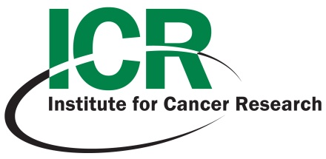

**ICR Grand Rounds Seminar**

“Novel NK Cell-mediated Immunotherapy for Cancer”

**Porunelloor Mathew, Ph.D.**

Associate Professor

Department

of

Molecular Biology & Immunology

UNTHSC

Fort Worth, TX

**Date: Wednesday**

**February 6, 2013**

**Time: 12:00 to 1:00 pm**

**Location: LIB-110**

**Lunch will be provided on first come basis.**

**Learning Objectives…**

*Those attending this presentation will receive educational information and be exposed to the following ideas and concepts to:*

1. **Immune Response to Cancer**

1. **Natural Killer cell receptors and regulation of NK functions by surface receptors**
2. **Molecular basis of NK cell recognition and activation by Cancer cells**

1. **Use of NK cell based targeted therapy for Cancer**