Instructions to Get Your
Certificate & Provide Feedback
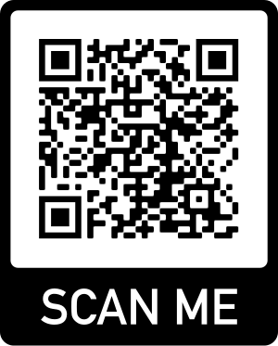
DEADLINE: November 13, 2021
Visit http://ce.unthsc.edu
in any web browser (Chrome, Edge, Firefox, Safari)

- Using your web browser, visit http://ce.unthsc.edu
- Click “Claim Credit” and Enter Code EKDIY. Click “Submit.”
- Sign in or create account by following prompts.
- Follow guide for claiming appropriate credit amount and type for the activity.
- View your certificate to print it now or return later to review your full transcript.
If you have any questions,
please call the office at (817) 735-2539
between 8 AM – 5 PM CT Monday-Friday, or e-mail register@unthsc.edu.

Canvas Clinic Faculty Development

Date: 10/14/2021
Format: Regularly Scheduled Series
Target Audience:
This activity is intended for faculty involved in graduate health professions education. Continuing education credits are available for: physicians, pharmacists, nurses, licensed professional counselors, and certified public health professionals. Others may claim participant credit.

Needs Assessment:
Canvas is the UNTHSC LMS for all for-credit courses. UNTHSC faculty and staff have minimum skills in Canvas. With more and more online courses, programs, certificates, and degrees offered online, the technical skills in online course development have fallen behind. Hence, competent e-Instructors are key to successful e-Learning implementations and they should have the appropriate skills and experience for the effective implementation of e-Learning and blended learning (Gulbahar and Kalelioglu, 2015). Along with new programs and transitioning programs, UNTHSC has seen an increase in adjunct professors. These professors often need extra training on our LMS due to a lack of exposure or experience. Many of these professors also have a minimal Canvas skill set. Adjuncts are often hired very close to the start of classes, teach for multiple colleges in the same semester, and hold full-time jobs that keep them from being able to attend tech trainings during the day (Street, Maisto, Merves, & Rhoades, 2012)

Objectives:
Upon completion of this activity, learners should be able to:
- Enhance course design.
- Demonstrate basic knowledge of Canvas LMS.
- Implement various Canvas tools.
- Apply Canvas assessment options.
- Establish a Canvas presence.
- Create a full-spectrum engaging course for delivery to students.

Disclosures:
In accordance with the appropriate accrediting bodies, all planners, teachers, and authors with control over activity content are required to disclose to the provider any relevant financial relationships (those held by the planner or significant other, currently or within the last 24 months) with commercial interests. Accredited providers are required to provide this information to learners before the start of an activity.
No planning committee member or faculty have any relevant ineligible financial or leadership relationships to disclosure
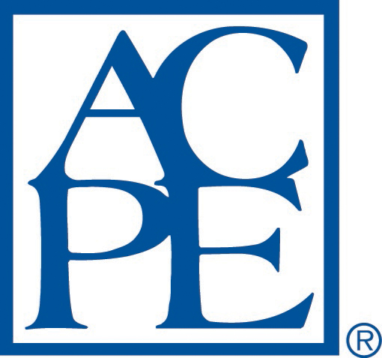
Accreditation Statement (statements are for the series through 12/31/2021):
Physicians
This activity has been planned and implemented in accordance with the accreditation requirements and policies of the Accreditation Council for Continuing Medical Education (ACCME). The University of North Texas Health Science Center is accredited by the ACCME to provide continuing medical education for physicians. The University of North Texas Health Science Center designates this live activity for a maximum of 5 AMA PRA Category 1 Credit(s)^{TM.} Physicians should only claim credit commensurate with the extent of their participation in the activity.
The University of North Texas Health Science Center is accredited by the American Osteopathic Association to award continuing medical education to physicians. The University of North Texas Health Science Center at Fort Worth designates this program for a maximum of 5 AOA Category 2-A credits and will report CME and specialty credits commensurate with the extent of the physician's participation in this activity.
Nurses
The University of North Texas Health Science Center at Fort Worth is accredited as a provider of nursing continuing professional development by the American Nurses Credentialing Center's Commission on Accreditation. This activity provides up to 5 contact hour(s).
Pharmacists
The University of North Texas Health Science Center is accredited by the Accreditation Council for Pharmacy Education as a provider of continuing pharmacy education. This knowledge-based activity has been assigned UAN #0845-0000-21-037-L04-P and will award up to 5 contact hours of continuing pharmacy education credit in states that recognize ACPE Providers.
Statements of participation will indicate hours and CEUs based on participation and will be issued online at the conclusion of the activity. Successful completion includes completing the activity and requesting credit online at the conclusion of the activity.
Credit will be uploaded to CPEMonitor, and participants may print a statement of credit or transcript from their NABP eprofile. UNTHSC complies with the Accreditation Standards for Continuing Pharmacy Education.
Public Health Professionals
This activity is approved for 5 credit(s) accepted by the National Board of Public Health Examiners' Certified Public Health (CPH) recertification program.
UNTHSC Participation Credit
The University of North Texas Health Science Center certifies this activity for 5 hours of participation

Conflict of Interest Disclosures:

In accordance with the appropriate accrediting bodies, all planners, teachers, and authors with control over activity content are required to disclose to the provider any relevant financial relationships (those held by the planner, currently or within the last 24 months) with ineligible interests. Accredited providers are required to provide this information to learners before the start of an activity.

The faculty and planner have no relevant financial relationships to disclose.

