Qualtrics
Learning Objective of this Document
To explore and use the tools and features to get started using Qualtrics to create effective online surveys.

What you can expect to learn from this training:

- How to utilize the Qualtrics interface
- How to use the tools in Qualtrics to create surveys
- How to customize the settings of a survey
- How to create questions in Qualtrics
- How to apply logic to questions
- How to edit questions and survey layout
- How to share surveys with colleagues
- How to distribute surveys
- How to view the results of a survey
- How to use the reporting tools in Qualtrics
- How to download and export Qualtrics data

Who should take this training?
Anyone who wants to learn the basics of Qualtrics to create surveys.

Qualtrics Tips and Shortcuts:
- Access Qualtrics from the following URL: https://unthsc.ca1.qualtrics.com
- Training and Help: https://www.qualtrics.com/support/
- Fill out a support ticket: https://www.qualtrics.com/support-center/
- Qualtrics Survey Platform Overview: https://www.qualtrics.com/support/survey-platform/getting-started/survey-platform-overview/

Getting Started
Before creating a survey consider how the survey will be used and the type of data you are interested in collecting.
- Think through your objectives in creating the survey.
- Who is the target population?
- Provide information on the purpose of the survey and how best to complete it.
- What will you do with the data, how will it be analyzed, and with whom will you share the results?

Steps for developing a survey in Qualtrics
- Think through the intention and development of your survey questions
- Create a survey
- Add questions and logic
- Distribute the survey.
- Analyze and share the results of the survey.

Help
Take online training using Qualtrics Base Camp: https://basecamp.qualtrics.com/?utm_lp=nav-text-link

Creating a Project
The Create Project button is on your homepage in Qualtrics.
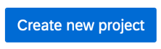
- Click on the Create new project button to begin a new survey. Click on Survey>
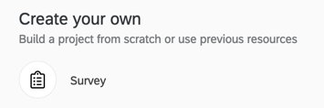
- Choose from the following options:
  - New Project: Build your project from scratch. Type in a project name and click Create Project.
  - From a Copy: Choose an Existing Project from your library, then Provide a New Project name.
  - From a Library: Copy a survey from the Qualtrics library. Use existing survey templates to begin with a survey that has been used before.
  - From a file: Select any. QSF file that is stored in your computer
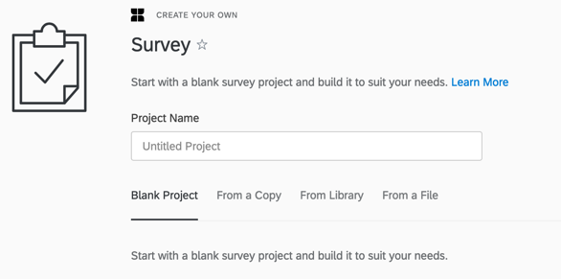
Once a selection is made, click Get Started and you are taken to the Survey tab.

Blocks
Your survey must create at least one Block. A default question block will be created for you when you first create a survey.

Blocks are sets of questions within your survey. Typically, questions are separated into blocks for the purpose of conditionally displaying an entire block of questions, or for randomly presenting entire blocks of questions. These branching and randomization options are found in the Survey Flow.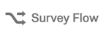

Blocks can also be used to organize longer surveys. For example, the first five questions in your survey might be in a block called “Screening Questions”, and the last ten questions in a block called “Main Questions”. Choose Block Options in the upper-right corner of the Block to edit options.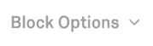

To add a new Block, click on the Add Block link at the bottom center of the Block window.

Adding questions
Twenty-three different question types are available. Any time you change the question type, you can make changes to the format.
- Click on the Create a New Question button to create a survey question.
The default question type is multiple choice OR click on the Import Questions From button to choose questions already developed in another survey or in the Qualtrics library.
- The Automatic Choices Feature will automatically create questions based on a typical question type. Click the check-box next to Automatic Choices to view the options. The editing panel is located to the right of the question.
- Choose to add a Personalized Answer within the given selection of automatic answers by editing one of the answers or adding a new answer. Then click on the text to view a down-arrow to the right and choose, Allow Text Entry.
- A Rich Text Editor is available for adding Bold, Italics, Underlined, etc. formatting. You can also add graphics, files and videos.
- Exclude from Analysis is an option the system provides for question data that will not be included in any Qualtrics calculations, i.e., Mean, SD.

Question Types
- Choose from a variety of question types, as there are 23 different item types. The four most commonly used questions are: multiple choice, matrix table, text entry, and descriptive text. Multiple choice is the default question type.
- To change the question type, select Change Question Type located to the right side of the screen.
- When you hover over a question type, a preview appears.
- Select the desired item type.

Descriptive Text and Page Break
Choose the Descriptive Text item type to introduce a new block of questions or provide an introduction. To insert a Page Break, click on the Page Break option, located on the right side of the page.

Display Logic
Used when you would like to display a single question based upon a previous response. Typically used when you have a single follow-up question. Begin by clicking on the question you would like to display or not to display. Then choose Add Display Logic. Follow the question options, as desired.

Skip Logic
Used when multiple follow-up questions are involved. Use Skip Logic to have participants skip to other questions in the survey block or go to the End of a Block or End of Survey. Refer to the Survey Flow section below to learn how to incorporate expanded Skip Logic options.

Carry Forward Choices
Carry Forward allows you to copy answer choices from one question and bring them into a future question in your survey. For instance, you can first show a question to your participant asking which products they have bought from your company in the last three months. You can then carry forward the choices they selected into the next question where they can then rank their preference.

Note: Make sure the question you are Carrying Forward is on a separate page or block than the question you are Carrying it Forward to.

Piped Text
With Piped Text, you can customize question and choice wording for each participant. When you add Piped Text to your survey, it will appear as a line of code, like this: ${m://FirstName}. When participants take the survey, this code will be replaced with unique content.

Note: Make sure the question you are piping from is on a separate page or block than the question you are piping to.

Look and Feel
The Look and Feel tool allow you to personalize the aesthetics of the survey, including the skin/theme, font, colors, header or footer of the survey. By default, a USF template will be applied to your survey to add branding to the survey.

To add your Department/School to the USF Template, choose the Header Text template from the list of templates, then click on the Advanced link. Type your Department or School name in the Header text box.

Copy Project
If you would like to make a copy of a survey and share it with another USF Qualtrics user, click the Copy Project option associated with the survey (click on the down-facing arrow to the far-right of the survey title). Choose Copy To: Other User, then type in the full account name, in our case it would be <EUID>#unthsc (that is a hashtag). For instance, rgs0014#unthsc.

Share Project
Use the Share Project option to allow you to share the task of building or analyzing your survey with another Qualtrics user. You can grant permissions for others to share the survey. You can grant permissions to others by allowing them specific functionality.
- Select the Share Project option from the down-facing arrow to the far-right of the survey title.
- You will first need to make sure that your colleague has logged into Qualtrics to create their profile.
- After they have done that, you can search for and add him/her.
- Once added, select the appropriate permissions and Save.

Survey Options
These are the permissions and settings that you will want to check before sending your survey out.

Note the following options:
- Allow respondents a back button if you would like your respondent the ability to go back as well as forward in the survey.
- Survey expiration dates. The default is one-week or 7 days.
- How partial responses are treated.
- Prevent Ballot Box Stuffing, if you don’t want people to take the survey more than once from the same computer.
- Anonymize Response. Do NOT record any personal information and remove panel association (not recommended).

It is important to review these before launching the survey.

Survey Flow
Survey Flow allows you to customize where participants go and what they see in your survey. It also gives you a quick overview of your survey and its subpages.

Participants will start at the top of the flow and work their way through until they reach an endpoint and finish the survey.

Question Numbers
The Q numbers (Q1, Q2, etc.) appear to the left of the survey questions. The questions are numbered based upon when the questions were added. If you would like to renumber the questions so that they are ordered sequentially. To do this, click on the Tools from Survey tab in the upper right-corner of the screen. Choose, Auto-Number Questions.

Distributing a Survey
Survey Link: The anonymous survey link doesn’t collect any personal information. Click on the Distributions tab to begin. Choose to activate your survey to collect responses by clicking on the Single Reusable Link option. Copy and paste the anonymous survey link into an email or webpage. It doesn’t collect any personal information and is designed for open access.

Email Survey: Click on the Emails link, then click on the Compose Email option. You are taken to the survey mailer, which allows you to select a list of responses. Don’t delete the three lines of code after the Follow this link to the Survey, as this is useful for managing the respondents (Follow this link to the Survey: ${l://SurveyLink?d=Take the Survey}) . And prevents individuals from taking the survey more than once or forwarding the link to others.

To begin:
- Click on the Contacts tab then click on the Create Contact List button.
- Create a Contact List Name.
  - Add Panel Members. Most basic way to add a small number of panel members.
  - Import from a File. Enables you to upload an Excel files with the panel member names. The file must be saved as a .csv file.
  - Import from a Survey.
- Once a survey panel is created, you can switch back to the Distributing a Survey tab.

View Reports
Click on the Reports tab to view the reporting options. Click on the Stats link in the top-right corner of the page to view quick stats about the survey.

In the Reports tab, click the Initial Report link to review the results of a survey. A summary of your data will be displayed. Use the question list in the left-hand panel to show/hide questions.

Select a question to view the results. Delete a table or graph by clicking on the x in the upper right corner of the chart or graph. Click on the Add Graph or Add Table button in the top right corner to view the relevant information. Select the More pull-down menu to see more options.

Subgroup: Add a subgroup to filter your data. Click on the Add Filter in the top left corner of the page.

Add Filter: Allows you to see multiple subgroups at once.

Report Options: Click on the Report Options menu on the right-side of the screen to select from a variety of reporting options.

Responses
Use the Data section of the Data & Analysis tab to clean up your data or take a quick look at an individual response. In addition, use Responses to Search responses, view responses statistics, view and delete Recorded Responses, View, close, delete, or download Responses in Progress, Import responses, Create a PDF report of an individual response, Issue retake survey links, Generate Test responses, Delete Survey Previews and Tests, or Imported Responses.

Download Data
Download your raw data in a variety of formats (Excel and SPSS, etc.) for further analysis of your data.

Cross Tabulation
Designed to show relationships among variables. Only used with multiple choice and matrix- type questions. Crosstabs are tables that can demonstrate relationships. P values <.05 indicate that there is a strong relationship.

Sample
A subset of a population that can be evaluated to make inferences about the population in question. Samples are usually randomly selected from the available population. The sample size needed to make inferences about the population can be calculated by CIPE.

Survey
Although surveys take many forms for the purpose of these guidelines, a survey refers to any instrument used to collect information, typically electronically, from groups of interest.

Data & Analysis Overview For specific data analysis help, contact
The Data & Analysis tab allows you to manage, add information to, and analyze individual participant responses. The tab is organized into three sections: Data, Text, Cross Tabs, and Weighting.

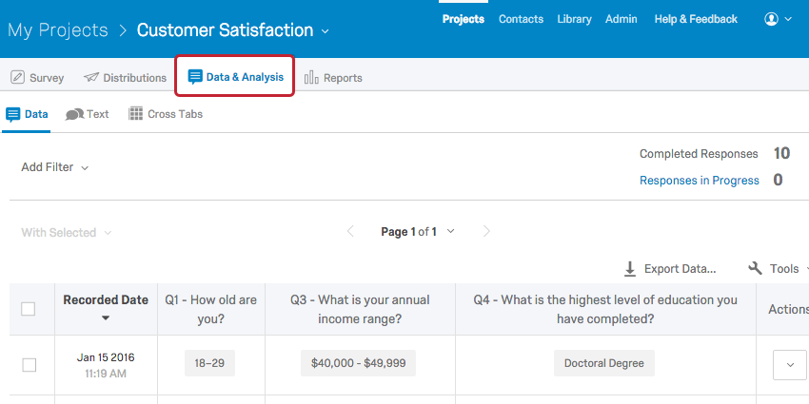

Across these sections, you can:
- View, filter, tag, and delete Recorded Responses
- Perform text analytics on Text Entry questions
- Create cross tabulations
- View, close, delete, or download Responses in Progress
- Export and import responses
- Create a PDF report of an individual response
- Issue retake survey links
- Delete Survey Previews, Survey Tests, and other types of responses

You can also view responses in the Data & Analysis page. These are split into two sections:
- Completed Responses: Responses that are closed and recorded in your dataset. These include responses submitted when a survey is completed and partial responses that are closed. For more information, visit our Recorded Responses page.
- Responses in Progress: Responses that have been started but not submitted or closed. Responses in Progress move to Completed Responses when a respondent submits their survey, the survey session is manually closed, or the survey session expires. For more information, visit our Responses in Progress page.

