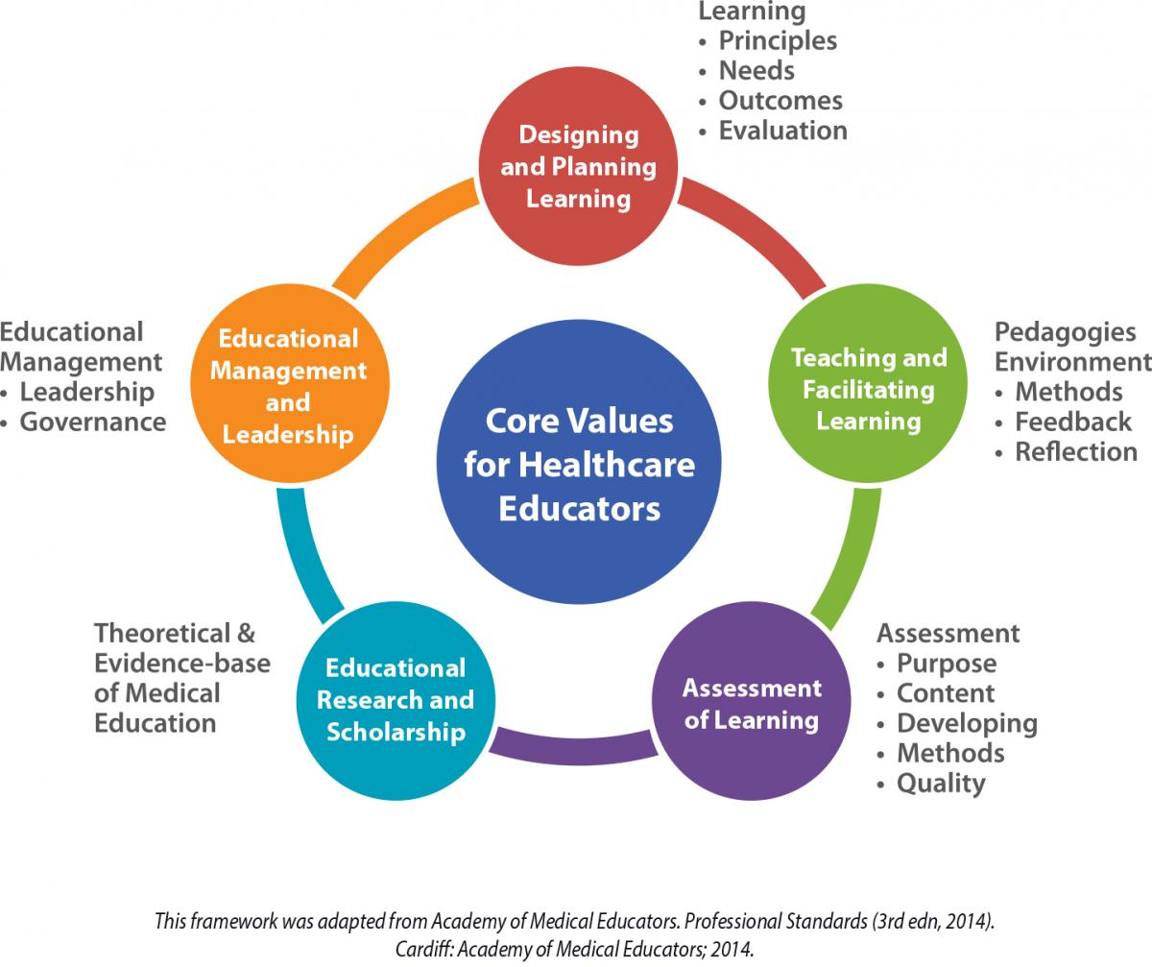

**A Framework for IPEP Faculty Development**

IPEP

This framework was adapted from Academy of Medical Educators, Professional Standards. Cardiff: AME, 2014.

**Core Values for Academic/Clinical Educators**