You can take attendance with Poll Everywhere using these four steps.
- Have your students follow the steps on the Registering with Poll Everywhere document.
- Receive your account information and log in to PollEverywhere.
- Create a simple multiple choice question with no obvious answer. In the class tell students what answer they must choose as the correct answer. This helps circumvent clever students who try and feign attendance. You can also set a timer to automatically lock the poll. See instructions below.
- Check the results of the poll by running the Gradebook report. Select the Gradebook as the report. You can download, print, or export this data to the Canvas gradebook.
- Attendance Best Practices

Taking Attendance

3. A. Ask your attendance question
Taking attendance is as simple as asking a question. Any question will do, but here’s an example that helps circumvent clever students who try and feign attendance.

Creating your attendance question
- Sign in to Poll Everywhere
- Click ‘Create’ and enter ‘What’s the Word of the Day?’
- Type in some responses, click check mark to set one as correct
- Click ‘Create’ to create your poll
- Select ‘Response Settings’ then ‘Registered Participants Only’
What you’ve done is create a multiple-choice question (‘What’s the Word of the Day?’) with no obvious answer. This question can be presented straight from the web, or embedded into any presentation. So, how do students know which answer to pick? You tell them. Simply tell your students which is the correct choice (or write it on the board). This way only students who are attending class will know the answer.
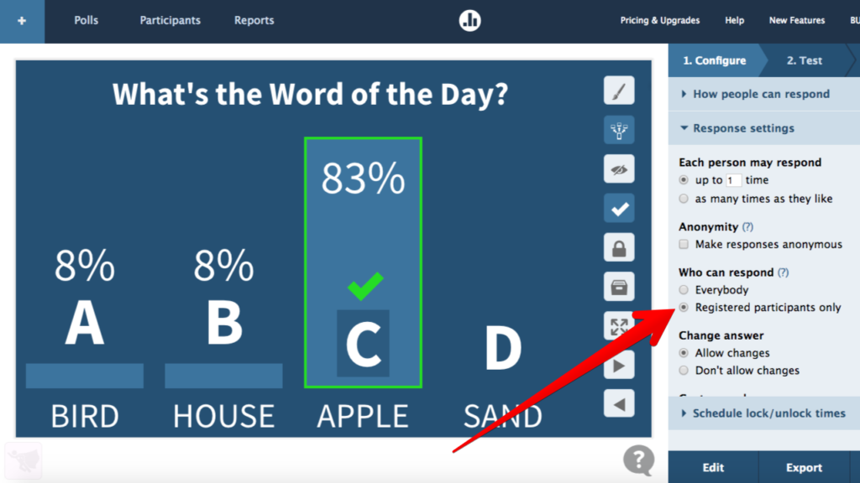
Tip: If you wanted added security against texting, enable a timer for your attendance question. Setting a short timer that automatically locks the poll will help prevent students from both entering their answer and swinging over to a messenger and texting their absent friends.

3.B. Check the results
This is where all that registering and grouping back in step one pays off. Once students have responded to your attendance question, you can create a report that shows exactly how each person answered. Poll Everywhere supports six different reporting types, but for this purpose let’s use a Gradebook report.

Running a Gradebook report
- Sign in to Poll Everywhere
- Click ‘Reports’ at the top
- Click ‘Create report’
- Select ‘Gradebook’
- Select your attendance question, click ‘Finish’
Your completed report will appear after a moment. Several names and response may appear if you’ve used this question multiple times. To sort through them, click ‘Participants’ on the left-hand side and use the drop-down menu next to ‘Group by’ to apply your different groups. Doing so will also display the names of students who are part of that group but did not reply to your question.
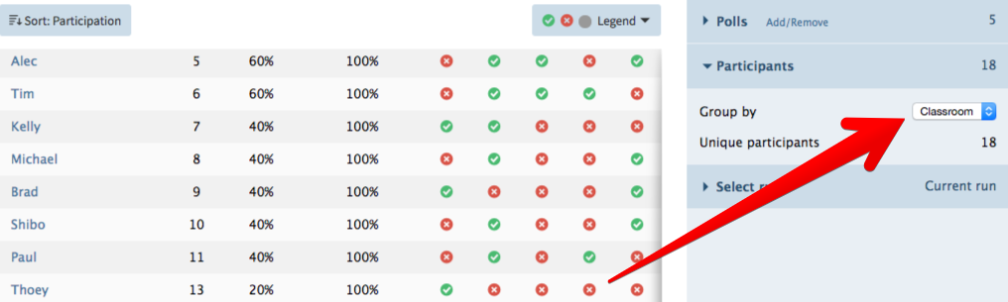
Once you’re satisfied, you can download, print, or export this data to Canvas.

