Step 1: Create a Poll

Go to https://www.polleverywhere.com/. Then, click on Login (upper right corner of page).

After logging in, click on Create Poll (upper left corner of page).

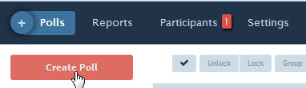

Next, click in the text-box and enter a question.

Then, choose the question type (the default is multiple choice) and add answers. Add more questions (optional). When finished, click on Create.

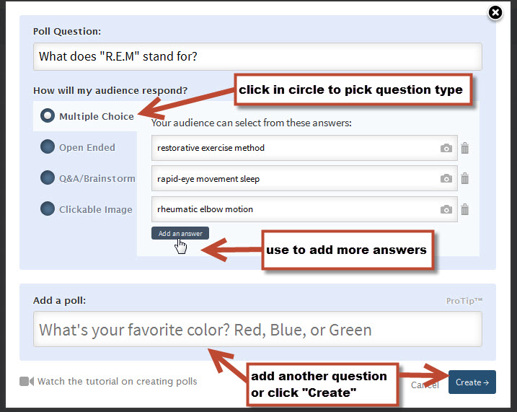

Step 2: Apply Settings for the Poll

Apply desired settings.

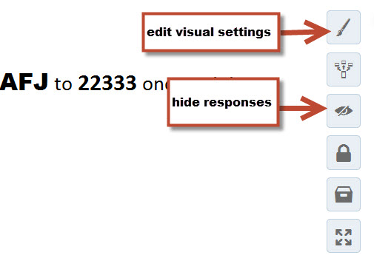

Decide how you want students to respond. The default for multiple choice and open-ended questions is website and text messaging. Q&A brainstorm and clickable-image questions are website only.

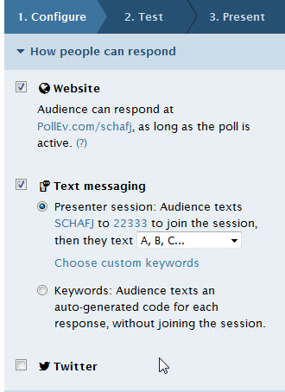

Click on Test and check the configuration before publishing the poll.

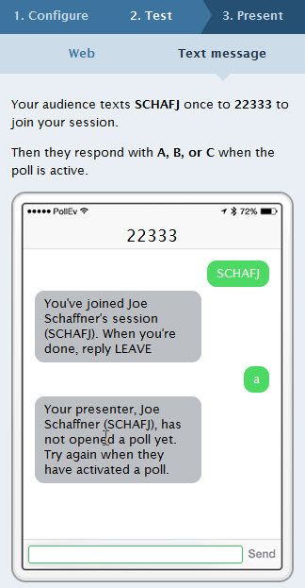

Step 3: Publish the Poll

Make the poll open for voting either by clicking on Present or by clicking on one of these buttons:

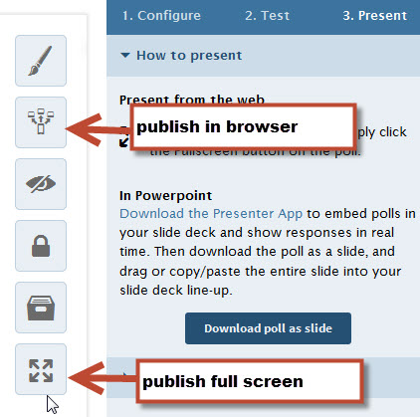

Step 4: Close the poll

After students respond, close the poll by clicking on this button:

