Step 1: Create a Poll

Go to https://www.polleverywhere.com/. Then, click on Login (upper right corner of page).

After logging in, click on Create Poll (upper left corner of page).

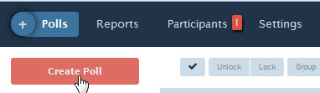

Next, click in the text-box and enter a question.

Then, choose the question type (the default is multiple choice) and add answers. Add more questions (optional). When finished, click on Create.

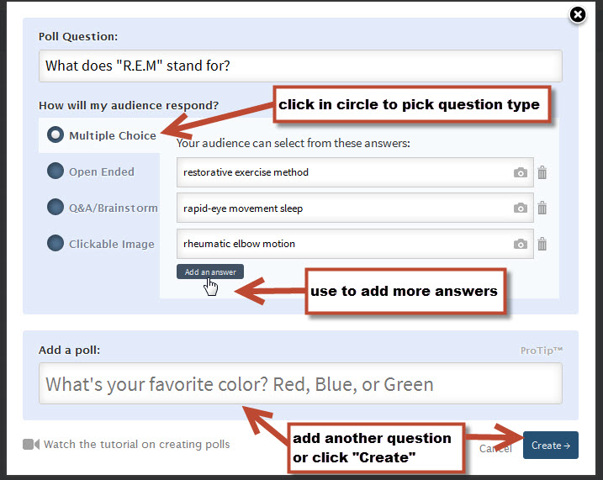

Step 2: Apply Settings for the Poll

Apply desired settings.

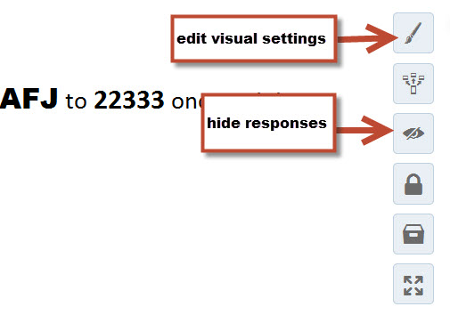

Decide how you want students to respond. The default for multiple choice and open-ended questions is website and text messaging. Q&A brainstorm and clickable-image questions are website only.

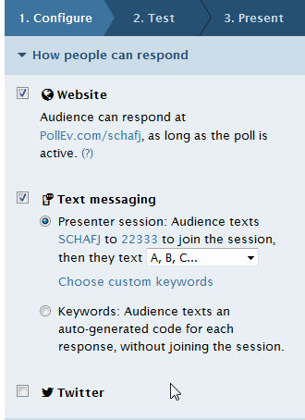

Click on Test and check the configuration before publishing the poll.

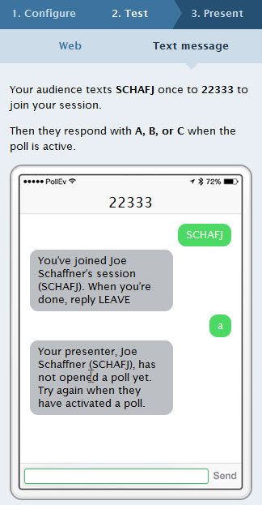

Step 3 : Publish the Poll

Make the poll open for voting either by clicking on Present or by clicking on one of these buttons:

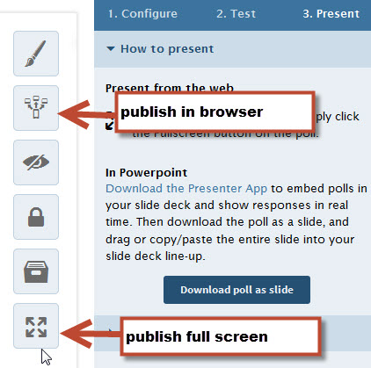

Step 4: Add Poll Link to a Canvas Module or Page

Instructions for how to add an item to a Canvas module. (https://community.canvaslms.com/docs/DOC-2827)

Please select “External URL” for the “Add Item to Module” portion of these instructions.

Please note we also recommend adding your poll’s text-messaging information (number and code) in the “Page Name” field when adding the link to the poll in Canvas so that students have the option to use text-messaging on their mobile devices to respond to the poll.

Step 5: Lock the Poll

After students respond, lock the poll by clicking on this button:

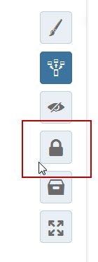

THE FOLLOWING STEPS ARE OPTIONAL. THEY SHOULD ONLY BE USED IF YOU WANT TO GRADE STUDENTS IN CANVAS FOR THEIR PARTICIPATION IN THE POLL.

Step 6: Create a “No Submission” Assignment in Canvas to set up a gradebook column for the poll.

To create a gradebook column, follow the steps for creating an assignment shell:

https://community.canvaslms.com/docs/DOC-2560

After you make the assignment shell, you must publish the assignment by following the instructions under "Publish an Assignment" in this link:

https://community.canvaslms.com/docs/DOC-2618

Important: You must publish an assignment for the column to appear in the gradebook. If you do not publish the assignment, the column will not appear.

Next, click on Grades (navigation sidebar) to see the column. The assignment will appear to your students in the "Assignments" and "Syllabus" areas of your site, as well as on the calendar display for your course. Since they will or will have already responded to the poll, you might want to tell them that this “new assignment” is where their grade for their participation in the poll will be recorded.

Step 7: Add Grades from Poll Everywhere to Canvas

Instructions for how to enter grades into the Canvas gradebook.

