iClicker Cloud Student Instructions
To participate using the Cloud version of iClickers, you will first need to make an iClicker Cloud account. Student accounts from iClicker Cloud are free for 2 weeks, and you will not be asked for any credit card information during the account setup process. Once you have created your account, you can request an access code to have your account activated as part of the UNTHSC site license (and therefore not be asked to pay to continue to use it).
PC/Mac/Laptop instructions
Visit the iClicker Cloud website here and create an account:
https://www.iclicker.com/students/apps-and-remotes/web
When prompted to identify your school, enter University of North Texas Health Science Center.
Login to your account, click the + icon in the upper right corner to add a course, select your institution, then begin typing the name of your course, which your instructor will give to you. This is the name of the course in iClicker, which may not be identical to the course catalog name.
Now that you have added the course to your account, you can participate in polls for that class by clicking the course name on this page. If an instructor’s poll has been integrated with Canvas, you can also launch iClicker Cloud by clicking the link within the assignment on Canvas. When a poll is in progress, you will be notified at the top of this page:
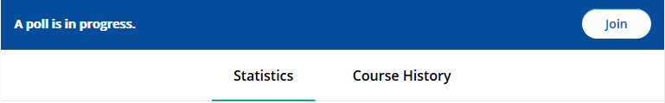
Click the Join button, then follow your instructor’s directions and the onscreen instructions in iClicker to complete the poll.
Mobile instructions
Download the iClicker Reef Student App on the Apple App Store or Google Play App Store depending on your device. Create an account, and when prompted to identify your school, enter University of North Texas Health Science Center.
Click the + icon in the upper right corner to add a course, select your institution, then begin typing the name of your course, which your instructor will give to you. This is the name of the course in iClicker, which may not be completely identical to the course catalog name.
Now that you have added the course to your account, you can participate in polls for that class by clicking the course name.
When a poll is in progress, you will be notified on the course page on your mobile device. Click the Join button, then follow your instructor’s directions and the onscreen instructions in iClicker to complete the poll.
Current students: associate your account with the UNTHSC Site License
Visit the link below and submit your account information. iClicker will process your request and send you an access code as soon as possible. This process is not immediate.
https://docs.google.com/forms/d/e/1FAIpQLSc_jWwRotjqhq7eUfx_7j7uU7HeFLOfxeBcTJ1Ghu5YMgEH5g/viewform
New students: associate your account with the UNTHSC Site License
Your department will have ordered a set number of iClicker Cloud accounts and will have been given an access code in return. Use the access code you have been given to associate your account with the UNTHSC site license.

