Using Microsoft E-Learning
For UNT Staff & Faculty Only

You are eligible to access Microsoft E-Learning courses online through the UNT Microsoft licensing agreement. These courses are meant to help you keep up-to-date with the latest major software releases. Please note that the access code we have received from Microsoft can accommodate a limited number of users from our organization. Do not share the code with unauthorized users. This is not permitted under our license agreement with Microsoft. Students are not permitted to access these courses.

In order to access the courses, you will need the following authorizations:
- A valid Windows Live™ ID. If you currently have a personal ID you may use that account. If not, you will be prompted to create an ID.
- The UNT Access Code (provided in Step #2 in the next section)
- A valid UNT, UNTHSC, or UNTSystem e-mail address

To gain initial access to the Microsoft® E-Learning courses

- Go to: https://business.microsoftelearning.com/activate/
- Read and accept the Data Sharing Notice
- Input your Access Code: IWO11DC02B
- Enter your unt, unthsc, or untsystem.edu e-mail address, click on “Enter”

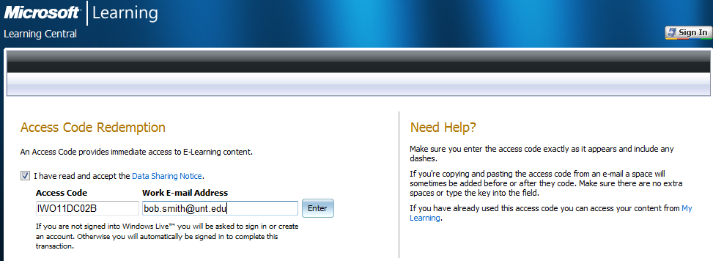

- You are then prompted to sign in using a valid Windows Live™ ID. (This is the user name and password you will use to access the site each time you log on.) If you do not have one, you can create one at this point.

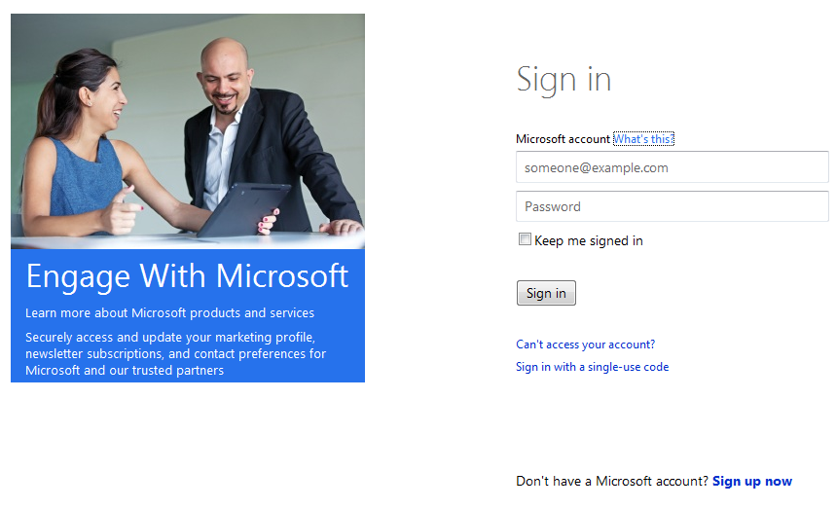
You must use a Microsoft account, if you do not have an account, click here to create one

- You will receive an e-mail confirming your registration
- After you are able to sign in, you may have to select an Agreement (Select Agreement No. 8516250) and then click on “Take Training”. See below:

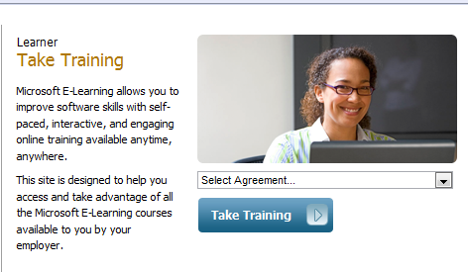

- Click on the Learning Catalog link to see a list of available courses

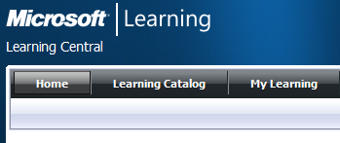

- Search the Catalog for courses that you are interested in

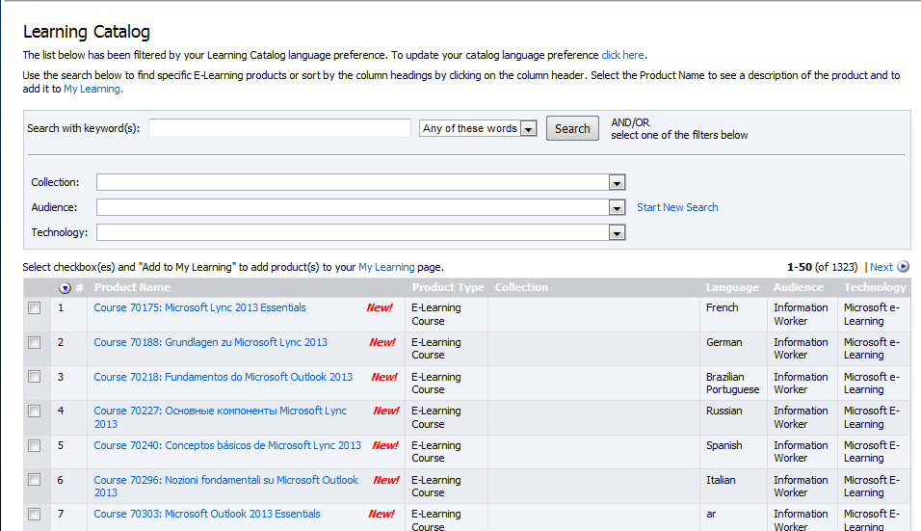

- Click a course title to launch the course. You have 12 months from the time of launch to finish that course.
- Create your personal learning plan by adding the courses you are interested in to “My Learning”
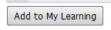

Accessing your course at any time

- Go to: https://business.microsoftelearning.com/
- Click the "Sign In" button in the upper right corner of the page
- Sign in to Windows Live using your Windows Live ID and password
- Select Agreement No. 8516250 and click on “Take Training”

- Click the My Learning button at the top of the page and begin your E-Learning course.
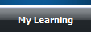

If you have any questions, please e-mail talentmanagement@untsystem.edu

