Patient Check-Out

Purpose:

To learn the basic steps which must be taken by front office staff upon the departure of a patient from any of our UNT Health clinics, in order to check that patient out of their scheduled appointment.

Objectives:

- Check-Out Process
  - Collect Any Remaining Payment Due from Patient
  - Enter the Patient’s Payment(s) in Gold
  - Schedule Follow-Up Appointment for Patient
  - Give Any Referrals to the RN or MA
  - Assist Patient With Any Questions or Other Needs

Importance of Patient Check-Out:

Patient check-out is the last opportunity for interaction with the patient prior to their departure from the clinic, so it is very important to make sure they leave fully satisfied with their visit. First impression at check-in sets the tone for the remainder of the appointment. Dealings with front office staff at check-out will be what patients remember after they leave.

This is the time to collect any remaining payment(s) due from the patient. The standard office visit co-pay or deductible should have been collected from the patient at check-in, but if for some reason it was not, it needs to be collected at check-out. In addition to confirming that the standard office visit co-pay or deductible has been collected, any additional charges resulting from procedures during the appointment must be collected.

If the patient needs a follow-up appointment that should be scheduled by staff at check-out. If any referrals are necessary, those are given to the RN or MA who are responsible for completing referrals at the clinic.

Make every effort to answer any questions the patient has at check-out time. Request assistance from doctors or other staff, if necessary. If the patient needs assistance with anything else, such as a Return to Work/School Note, be sure to handle for them at this time.

Check-Out Process

Patient Check-Out

Collect Any Remaining Payment Due from Patient

Collection of Patient Payments

Even though the patient should have already submitted payment at check-in, there may be certain treatments or procedures (labs, blood work, X-rays, etc.) they underwent during their appointment which were not covered by their standard office visit co-pay or deductible. That is why it is necessary to verify at check-out whether or not the patient owes any additional payment above and beyond what they paid at check-in.

Also, it might be the case that for one reason or another, the patient’s standard office visit co-pay or deductible did not happen to get collected at check-in. When reviewing the patient’s account at check-out, make sure that they already submitted their standard office visit co-pay or deductible at check-in, if one was due. This involves checking Gold and closely reviewing the Daily Audit Summary to ensure account reconciliation.

Enter the Patient’s Payment(s) in Gold

POS (Point of Service)

  - To begin the process of entering the Patient’s Payment(s) in Gold, select “Patient Management” from the list of Front Office Functions on the main menu.

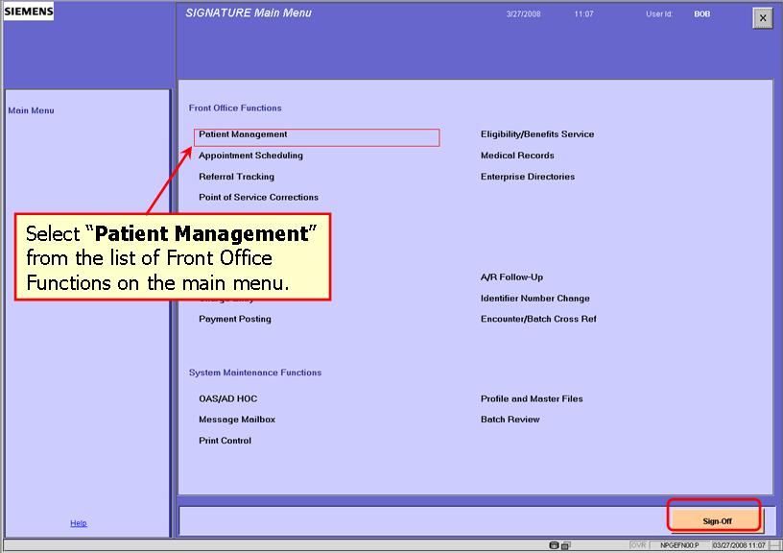
  - Enter the Patient’s Name and select “Search”

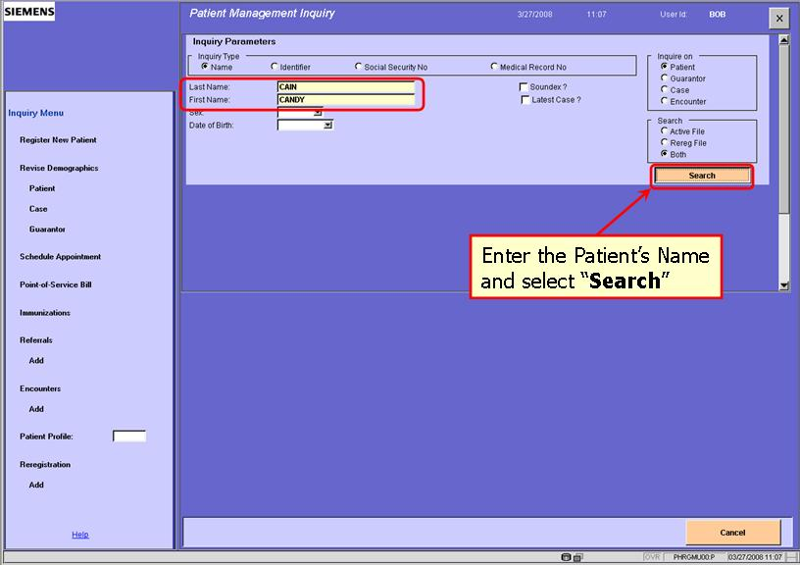

  - Select “Encounters” from the Patient Verification menu on the left.

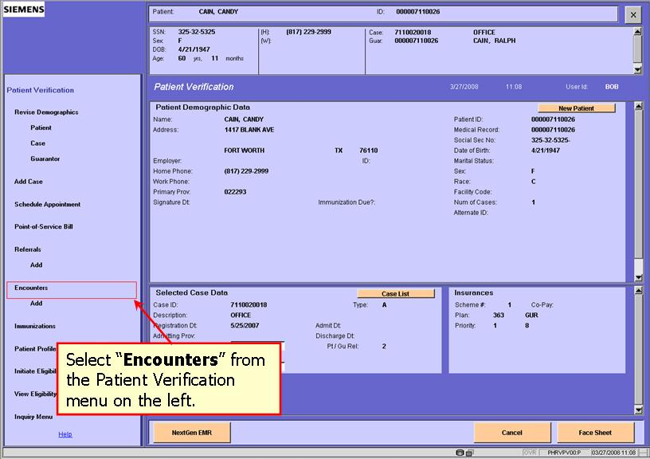
  - Highlight the desired Encounter, then select “Point-of-Service Bill” from the Encounter List menu on the left.

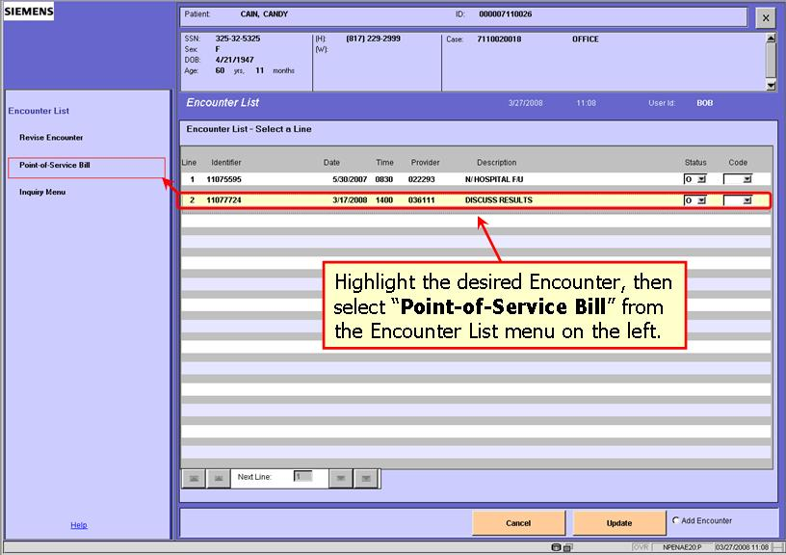

  - Make note of the Batch # listed in the upper right-hand corner, then select “Payments”

KEY POINT: It is extremely important to be sure and write down the Batch Number, as it will be needed later when the Batch is prepared and closed for the day.

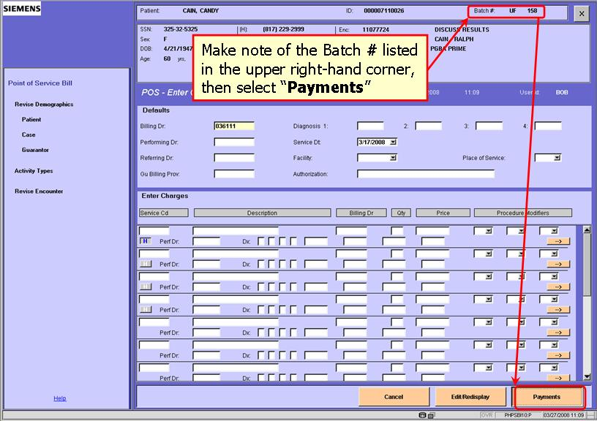
  - Enter the Payment Amount submitted by the Patient.

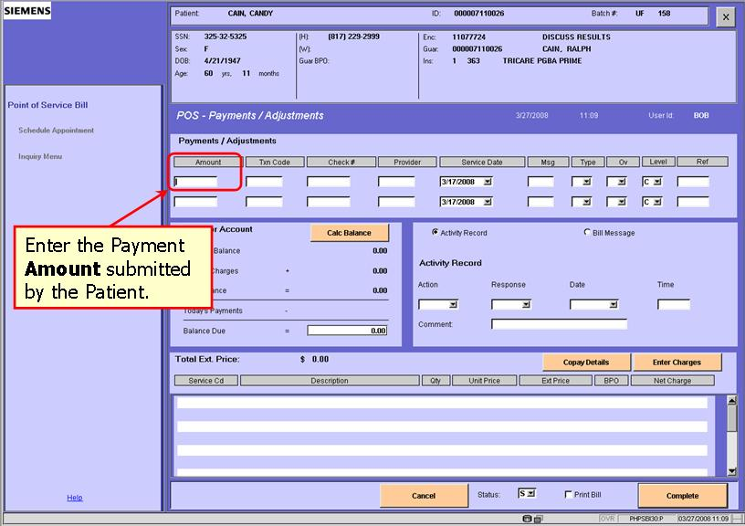

  - Enter the Txn Code (Transaction Code), which will always be “75” for a co-pay. If the payment is not a co-pay, use one of these transaction codes:
- 18=Cash
- 26=Check
- 34=Money Order
- 83=Credit Card

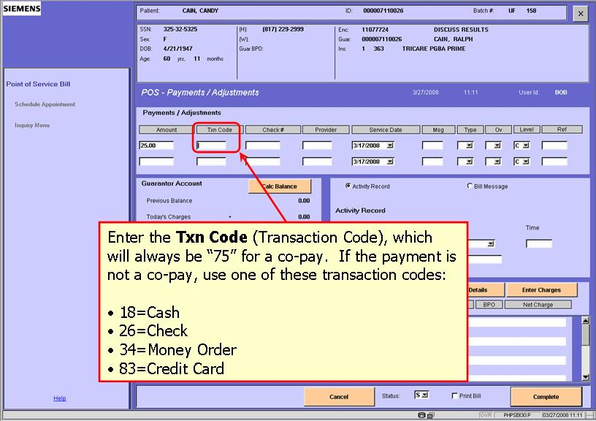
  - Enter the Check # (only if the Patient is making Payment by Check).

KEY POINT: Since the Payment is being entered under a specific Encounter, the Provider field should be left blank, because it will be automatically tied to the Provider listed on the Encounter. There is also no need to make any changes to the Service Date, as it is also tied directly to the Encounter.

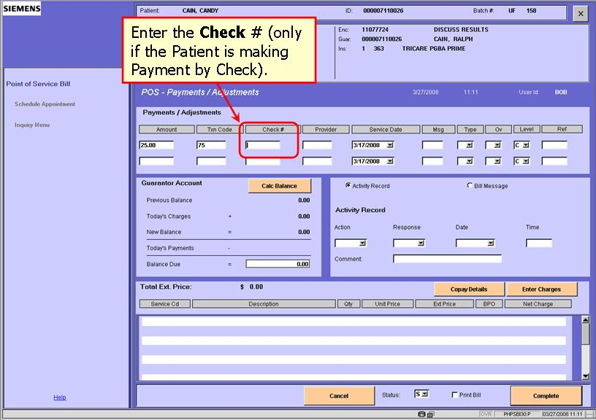
  - Enter the Payment Type from one of these available drop-down options:
- 1=Check
- 2=Cash
- 3=Credit Card
- 4=Debit Card

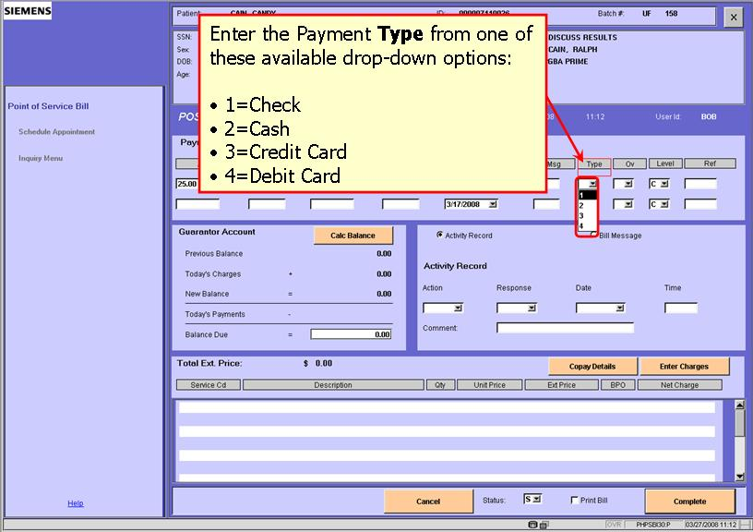

  - Enter the Ov (Payment Posting Override), which will be “2” whenever a Patient is paying for same-day services. Access Help Mode for a complete list of Ov Codes.

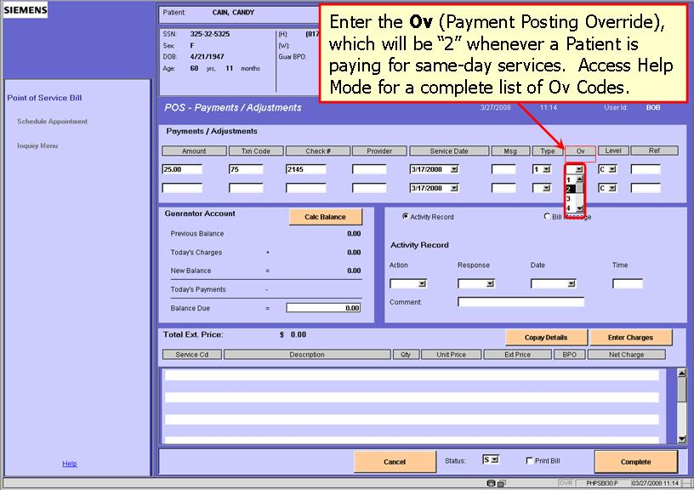

  - Enter the Payment Level, which defaults to “C” – allocate the payment to charge(s) on the selected case. Access Help Mode for a complete list of Level Codes.

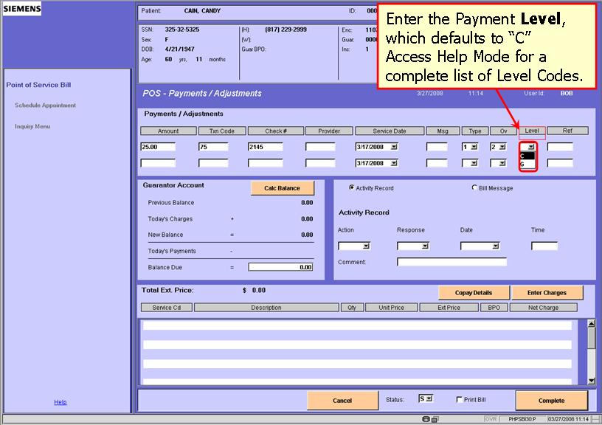
  - Use the Ref (Reference) field to specify a Payment that was not made by Check, using these guidelines:
- Credit Card: Enter the Approval Number
- Money Order: Enter the Reference Number
- Cash: Enter “CASH”

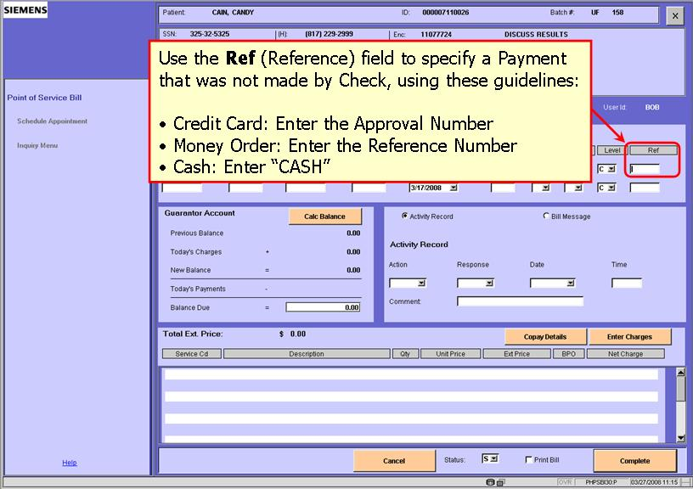

  - Select “Print Bill”

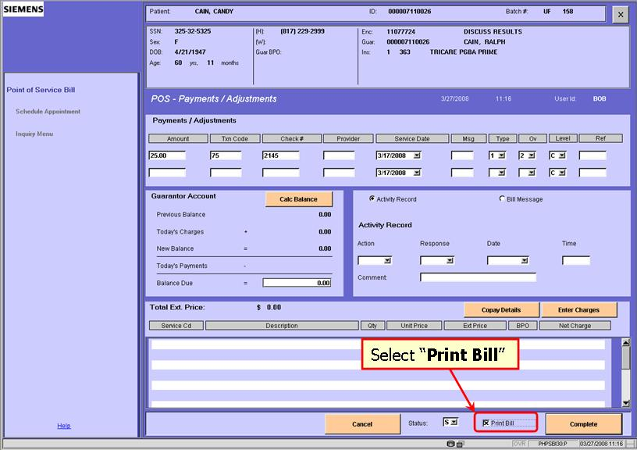

  - Select “Complete”

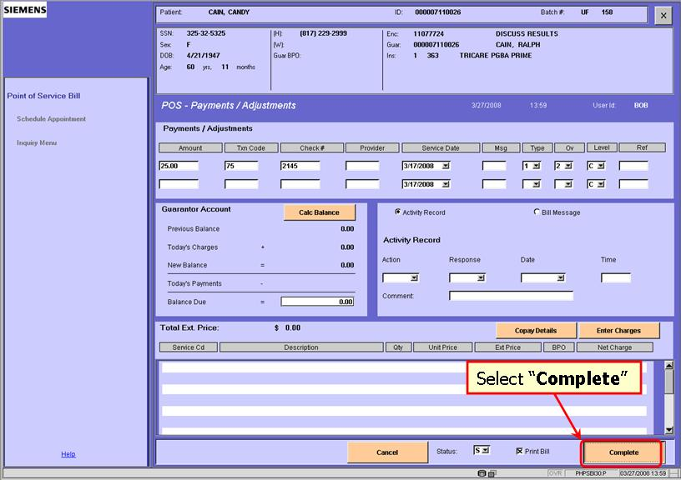
  - The system generates a “Transactions Accepted and Bill Printed” confirmation message.

HOT TIP: Even though it is referred to as a “Bill” in Gold, the document is actually a Receipt given to the Patient, which itemizes the amounts billed and paid for services received during their Appointment.

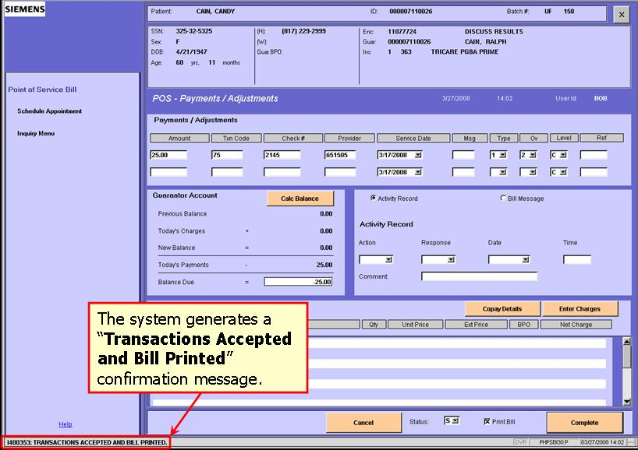

  - This is what a sample Bill looks like, once it has been printed from Gold:

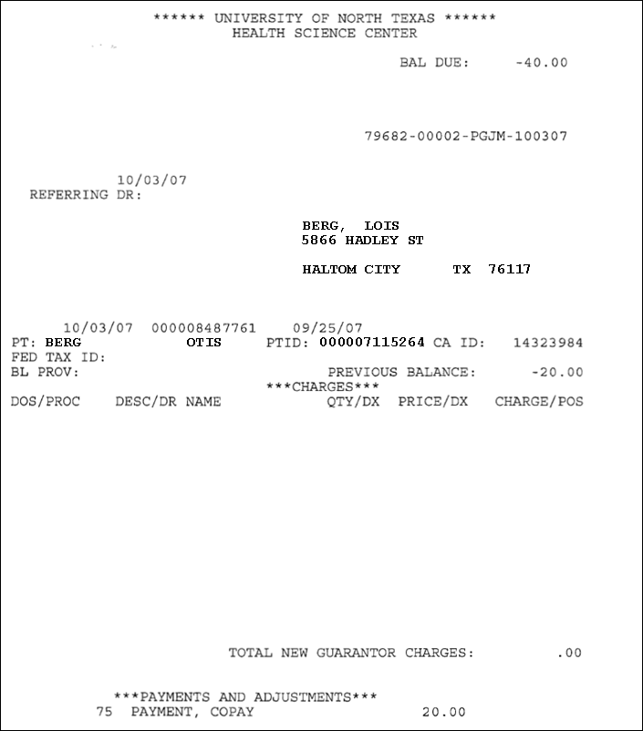

Schedule Follow-Up Appointment for Patient

Depending on the nature of the patient’s visit to the clinic that day, the doctor may need them to have a follow-up appointment scheduled. In those cases, the doctor will specify a timeframe for the patient’s follow-up appointment (i.e., around six weeks, in about 90 days, etc.). Find the next available date and time that works best for the patient, then schedule the follow-up appointment in Gold using the scheduling process detailed in Chapter 4 of this manual. Abbreviate in the description field as “FU.” It is important to both adhere to the doctor’s requirements, while also accommodating the patient’s availability.

Give Any Referrals to the RN or MA

If a referral is required for a patient to see a doctor at the clinic (typically needed for certain specialists), it will usually specify the number of allowed visits and the amount of time the patient has to complete those visits. These referrals should be given directly to one of the Registered Nurses (RNs) or Medical Assistants (MAs) at the clinic.

If at a specialist, be sure to review the patient’s referral status with them at check-out, so they will know how many visits they have remaining on their current referral, as well as any upcoming time/date-related restrictions (expiration of current referral).

Assist Patient with Any Questions or Other Needs

Be sure to fully answer any questions the patient may have at the time of check-out. Seek assistance from other staff or doctors, if unable to answer the patient’s query. Responding, “Let me find out for you,” is always preferable to, “I don’t know.”

If the patient needs assistance with anything else before leaving, such as a Return to Work/School Note, this would be the time to handle such items for them. Another example of something a patient might request at check-out, especially at a Pediatrics or Family Medicine Clinic, would be a young child asking for stickers. Clinics who routinely see children will typically have a place where stickers are kept to give out to kids asking for them at the end of their visit.

It is always important to make the patient comfortable throughout the duration of their visit to the clinic, and keeping them informed helps ensure their comfort level with the current and any upcoming visits. The more they know and understand, the more relaxed they will be.

