Clinic Cash Management

Cash Handling

Purpose --- For new employees to gain a better understanding of cash management, batching, and reconciliation within the clinic environment relating the importance to the billing process.

Objectives:
- Importance of Cash Management
  - Co-Pays
  - Deductibles
  - Cash Paying Patients
- Methods of Payment
  - Cash
  - Credit Card
  - Check
  - Money Order
  - Payment Agreement
- Credit Card Machine Operations
- Daily Cash Management Process
  - Daily Set-Up and Maintenance
  - Daily Reconciliation

Importance of Cash Management

Cash Management is a critical process within the clinics. First, tracking the management of patient payments establishes accountability to: 1) patients 2) the clinic 3) YOU ☺ Accountability in respect to completing the visit process and initiating the billing process. This section will walk through the cash management process from the start of the day to the completion and submission of daily deposits.

When a patient first arrives to their visit their insurance has already been verified and annotated on the “Face sheet” “Labels” or “Daily Schedule.” This allows all members of the clinic to know what a given patient owes when they arrive for their appointment.

There are three reasons a patient would be providing payment at the time of their visit:
- Co-Pay
- Deductible
- Cash paying patient

Co-Pays -- Another way of sharing medical costs. You pay a flat fee every time you receive a medical service (for example, $25 for every visit to the doctor). The insurance company covers the rest of the payment for the patients visit.

Deductible -- The deductible refers to the amount of money that the insured would need to pay before any benefits from the health insurance policy can be used. This is usually a yearly amount so when the policy starts again, usually after a year, the deductible would be in effect again. Some services, like doctor visits, may be available without meeting the deductible first. Usually there are separate individual deductible amounts and total family deductible amounts.

*** During your OJT you will learn how your particular clinic collects deductibles ***

Cash Paying Patient – There are individuals who pay out of pocket for their visit. These individuals pay cash, credit, check, etc… for the visit. ** Be aware of how your clinic handles cash paying patients… each clinic has different procedures.

Having a good understanding of how each patient pays establishes the foundation by which collecting payments and management of the process works. With this being said, let’s take a look at the various methods of payments.

Methods of Payment

Within the clinics there are 5 payment methods which patients can pay their bill (if they have a bill to pay at the time of service).

- Cash
- Credit Card – Not every clinic has the same manufactured credit card machine. Upon arrival to the clinic a quick review of how to operate the machine will be provided
- Check – Be sure on every check that the case or encounter # is listed as well as the patients SSN
- Money Order – This serves as a cash payment when reconciling
- Payment Agreement – There are times when a patient arrives and is unable to pay the entire bill. A “Payment Agreement” can be established between the patient and the clinic.
  - The following is a copy of a Payment Agreement followed by an example of a completed one.
*** Clinic Supervisors are closely involved in setting up the Payment Agreement with the patient. ***

*** Every clinic has petty cash on hand that is used to provide change. Petty cash is accounted for daily as part of the reconciliation process. ***

Blank “Payment Agreement”

Completed “Payment Agreement”
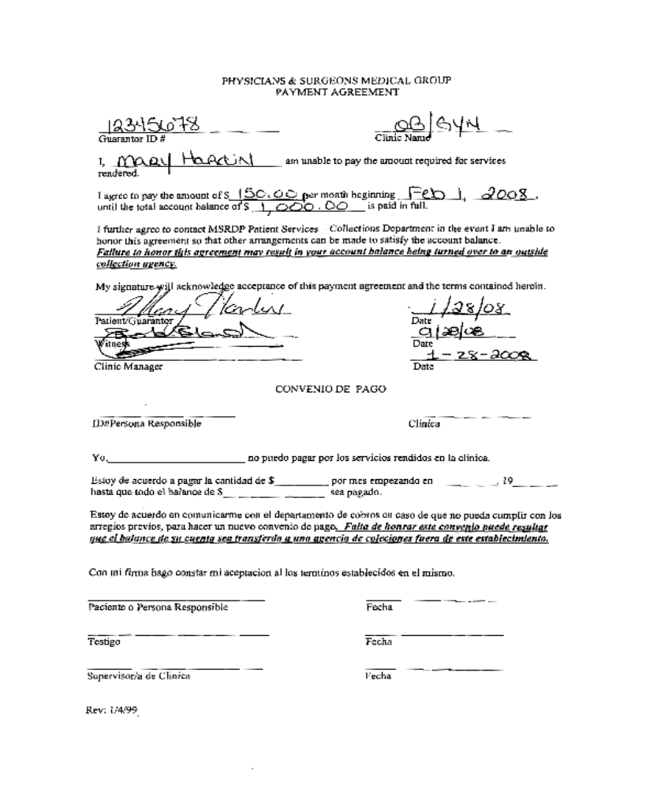

Credit Card Machine Operations and Security

Every clinic has a credit card machine. The manufacture might be different. Part of your On-the-Job (OJT) training will be to learn the actual operational function. It is best to learn this when a patient is actually paying so you can see how your specific clinic operates and it is much better seen in actual then in a training environment. Understanding the security and legal reasons behind operating credit card machines is an important aspect to clinic operations.

Daily Cash Management Process

1) Before the first patient arrives pullout a new “Daily Audit Summary”
  - In multiple functioning clinics each individual will maintain their own audit sheet.
  - Fill out the top part of the form first thing in the morning:

*** It is helpful to establish a routine, for completing the Daily Audit Summary, once patients begin arriving you will find that “time” becomes a limited resource. ***

- When entering your “Point of Service” (POS) in Gold it is best to annotate the check number and the Credit Card approval number. The reason is at reconciliation it is easier to decipher which payment belonged to which patient. It is also at this time that the daily Batch # will appear in the top right corner of Gold. This is a good time to write the Batch # on the top left corner of the “Daily Audit Summary”

*** If there are multiple individuals entering payments (POS) in Gold keep in mind there will be a different Batch # for each person. ***

*** It is best to update POS throughout the day so that evening closeout is smooth and not a frustrating process --- trying to figure out what payment belonged to which patient. ***

- Be sure that all payments are kept in a secure location. Every clinic has a lockbox for security and accountability purposes. Be sure that the lockbox is secure at all times. Each clinic has a specific process for securing payments throughout the day. There might be an individual who is designated to handle all payments for reconciliation at the end of the day. Be sure that you are aware of your clinics’ process.

Daily Reconciliation

1) Once the last patient has made their payment and it has been entered in Gold and on the “Daily Audit Summary” one individual is identified to collect and reconcile all payments for the day. If you are part of a multiple functioning clinic where each individual completes their own “Daily Audit Summary as well as their own “Cash Reconciliation Detail Totals Report” (this will be the reconciliation):

a. At the end of the day reconciliation between Gold and the “Daily Audit
Summary” occurs before the final deposit is turned in.
  - Final individual reconciliation includes: the “Cash Reconciliation Detail Totals Report” and “Daily Audit Summary” comparison & Closing the Batch
*** When printing required documentation from Gold make two copies one for the clinic records and one for deposit ***
  - Once all the required documentation has been printed final reconciliation begins. Review the “Daily Audit Summary” with the actual payments (cash, check, etc…). It is critical to ensure that the payment amounts are annotated in the correct columns. (See completed Daily Audit Summary) Once all payments are listed add up each column at the bottom.

  - Once you have added each of the columns now the “Daily Audit Summary” is compared to what Gold shows. There are two pages the Gold “Cash Reconciliation Detail Totals Report”:
  - Page 1 -- lists all the patients and what they paid that day. This is a summary of the “Point of Service” entries
  - Page 2 – lists the totals by Payment Type
*** The best practice is to compare Page 2 with the “Daily Audit Summary” and if there are any discrepancies refer to Page 1 to identify where something might be missing or need to be added. This is another reason why it is best to complete the “Point of Service” throughout the day so that during reconciliation there are no gaps in payment amounts between the pieces of documentation. ***

  - Once the “Daily Audit Summary” and “Cash Reconciliation Detail Totals Report” have been verified and are accurate than the bottom of the “Daily Audit Summary” should be completed.

5) After each column is added at the bottom left of the “Daily Audit Summary” there
are four boxes identified:
a. Total Collections/Payments – this is the total of ALL payments
  - Amount Over + (Short) – annotate here any overage or shortage in payments
  - Total Deposit – this is the total of ONLY the Cash and Checks (Money Orders are considered “Cash”)
  - Ending Change Fund Balance – reflect here the ending amount in Petty Cash
  - After completing each of the four boxes take one last look over all the documentation for proper annotation. Once everything matches sign the bottom and provide the following documentation to the clinic designee:
a. “Daily Audit Summary”
b. Patient payments (Cash, check, credit card, money order)
c. “Cash Reconciliation Detail Totals Report”

*** Once you have completed your reconciliation and your designee has reviewed all documentation then the last piece is ready to be accomplished --- Closing the Batch ***

Important Things to Remember About Reconciliation

A) When reconciling in Gold all operations will be done in the Main Menu Section titled “Business Office Functions.”

B) It is important to note that all reconciliations are done at the end of each business day. There are rare exceptions where reconciliation is done the morning of the next day… BUT this is not the accepted standard. Before you leave everyday you must reconcile and close your individual batch.

C) The evening reconciliation is an official end to clinic operations and the accountability phase of billing for the clinics. Therefore, it is critical that when handling payments or closing the batch that appropriate attention is given solely to this function. If there is any concern about rushing the process…. let someone know immediately.

D) On all checks include the patient SSN and the Case/ Encounter ID. This assists in the reconciliation when matching up payments and patients.

“Blank” Daily Audit Summary Form
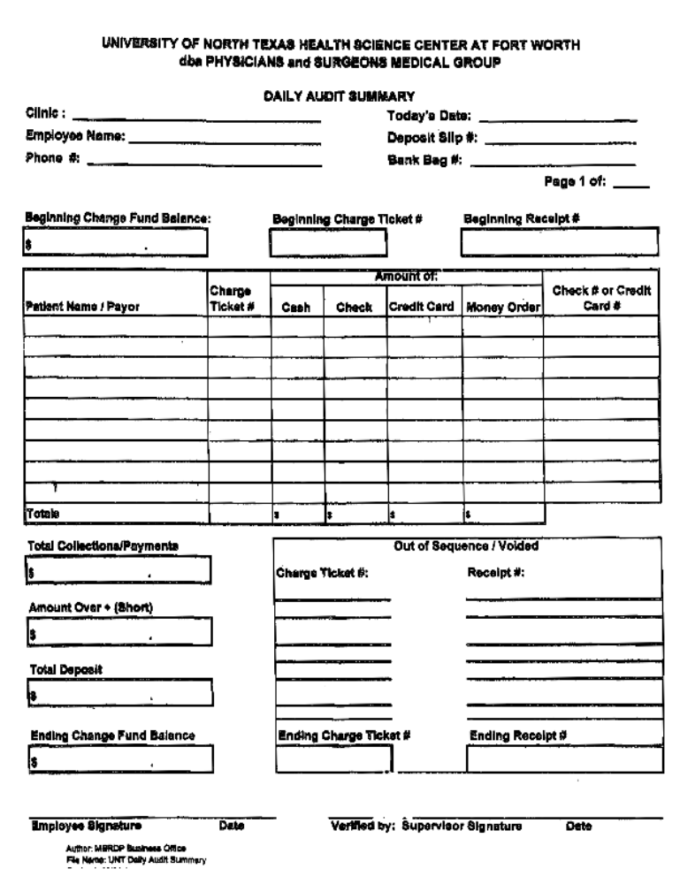

“Completed” Daily Audit Summary Form

