Accessibility Features on Mac
From www.support.apple.com 5/2022
On Mac, choose Apple menu > System Preferences, then click Accessibility.

Vision
Use these features to zoom in on the screen, make the pointer or menu bar bigger, apply color filters, and more. Or have your Mac speak what’s on the screen.

VoiceOver
Use VoiceOver, the built-in screen reader on your Mac, to speak what’s on the screen, and the text in documents, webpages, and windows. With VoiceOver, you can control your Mac with the keyboard, trackpad gestures, or a refreshable braille display. To customize VoiceOver, use VoiceOver Utility. See the VoiceOver User Guide.

Zoom features
- Make content on the screen larger and easier to see by zooming the entire screen or an area of it. If you’re using a second display, you can set the zoom for it separately. See Change Zoom preferences for accessibility.
- Use Hover Text to zoom whatever is under the pointer—for example, text, fields, menu items, or buttons—in high resolution in a separate window. See Use Hover Text.
- If your Mac has a Touch Bar and items in the Touch Bar are hard to see, turn on Touch Bar zoom to display a larger version of the Touch Bar on the screen. See Zoom in on the Touch Bar.

Display features
- Change the appearance of the screen by setting options to invert colors, adjust contrast, reduce transparency, or use shapes to convey status information. You can also stop or reduce motion on the screen—for example, when you open apps. See Change Display preferences for accessibility.
- Make it easier to find the pointer on the screen by increasing its size or making it bigger only when you quickly move it, or by changing its color. See Change Pointer preferences for accessibility.
- Apply a color filter to adjust the display colors or to tint the entire screen to make it easier to read text. See Change Color Filters preferences for accessibility.

Spoken Content features
Customize the voice your Mac uses to speak text, and have your Mac speak announcements, items under the pointer, and whatever you type or select. See Change Spoken Content preferences for accessibility.

Descriptions
Listen to a description of the visual content in movies, TV shows, and other media, if available. See Change Descriptions preferences for accessibility.

Hearing
Use these features to show and customize captions on the screen, make and receive Real-Time Text (RTT) calls, and more. See macOS accessibility features for hearing.

Audio features
Have the screen flash when alerts or announcements occur, and play stereo audio as mono. If you have a Mac with Apple silicon, you can choose whether Spatial Audio follows the movement of your head when you listen to spatial audio content. See Change Audio preferences for accessibility.

RTT features
If your Mac supports it, set up your Mac to make and receive RTT calls. See Change RTT preferences for accessibility.

Captions features
Control how subtitles are styled, and whether to use closed captions and SDH instead, when they’re available. See Change Captions preferences for accessibility.

Motor
Use these features to control your Mac and apps using spoken commands, the Tab key, an onscreen keyboard, the pointer, or assistive devices. You can also set options that make it easier to use a mouse and trackpad. See macOS accessibility features for mobility.

Voice Control features
- Use Voice Control to dictate text and speak commands to edit text, navigate the desktop and apps, and control your Mac, performing tasks such as scrolling in a document or pressing a button. See Control your Mac and apps using Voice Control.
- macOS provides a standard set of Voice Control commands, and you can create your own commands. See Create a custom vocabulary.
- If the name of an item on the screen isn’t apparent or you need to interact with a precise area of the screen, you can overlay the screen with numbers on each item or a grid so it’s easier to select items or navigate the screen. See Use item number and grid overlays.

Keyboard features
- When you turn on Full Keyboard Access, you can navigate all UI elements on your Mac using the Tab key and other keys, instead of a mouse or trackpad. See Navigate your Mac using Full Keyboard Access.
- Sticky Keys and Slow Keys make it easier to press keys on a physical keyboard. See Change Keyboard Hardware preferences for accessibility.
- Use the Accessibility Keyboard, an onscreen keyboard that lets you use your Mac without a physical keyboard. It provides advanced typing (such as typing suggestions) and navigation features that you can customize for using your favorite apps. See Use the Accessibility Keyboard.
- When you use the Accessibility Keyboard, you can turn on Dwell to perform mouse actions using eye- or head-tracking technology. See Control the pointer using Dwell.

Pointer Control features
- Set options to make it easier to use the mouse and trackpad. For example, adjust the mouse or trackpad’s reaction time when you double-click an item, or drag items with or without drag lock, or with a three-finger drag. See Change Mouse & Trackpad preferences for accessibility.
- Mouse Keys lets you move the pointer and press the mouse button using the keyboard or a numeric keypad. See Control the pointer using Mouse Keys.
- Alternate pointer actions let you perform mouse actions (such as a left-click or drag-and-drop action) using keyboard shortcuts, assistive switches, or facial expressions (such as a smile or an open mouth). See Change Alternate Control Methods preferences for accessibility.
- Use head pointer to move the pointer based on the movement of your face or head, as detected by the camera that’s built into or connected to your Mac. See Move the pointer using head pointer.

Switch Control
Switch Control lets you use one or more adaptive accessories to enter text, interact with items on the screen, and control your Mac. Switch Control scans a panel or the user interface until you select an item or perform an action using a switch. See Use Switch Control.

General:
Use these features to easily turn various accessibility features on or off, and to type your Siri requests. See macOS general accessibility features.

Siri
Type your Siri requests instead of speaking them. See Change Siri preferences for accessibility.

Shortcut
Quickly enable or disable various accessibility features using the Accessibility Shortcuts panel. See Change Shortcut preferences for accessibility.

Use the Accessibility Shortcuts panel on Mac
The Accessibility Shortcuts panel offers shortcuts to quickly turn on or turn off common accessibility features such as Zoom, VoiceOver, and Sticky Keys.
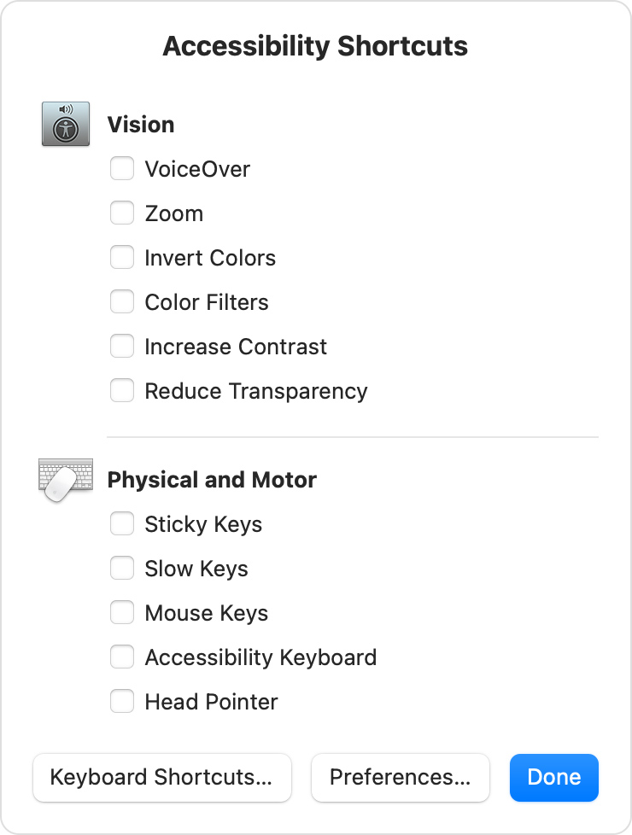

Open the Accessibility Shortcuts panel
Press these keys together: Option (⌥), Command (⌘), and F5. On notebook computers with a Touch Bar, you might need to press the Fn (Function) key as well.
On notebook computers with Touch ID, triple-press Touch ID. (If you press and hold the Command key while doing this, VoiceOver turns on or off.)
To close the panel, click Done or click anywhere outside of the window.

Change the shortcuts in Accessibility Shortcuts
To change the shortcuts that appear in the panel, choose Apple menu > System Preferences, then click Accessibility. Select Shortcut in the sidebar, then use the checkboxes to turn shortcuts on or off.

