Accounts Request App
What it is:
The Accounts Request app replaces the paper-based method of requesting accounts or access to secure resources.
Why change?
The paper-based method had limitations. Requesters could not track the status of their requests. Access often has to be approved or setup by additional parties. The new system will speed the process of granting account access, while making it easier for users and ITS to track requests.
How the process works:
- You can request access for yourself or someone else. Login with your EUID and AMS password at https://apps.unthsc.edu/accounts to begin a new request.
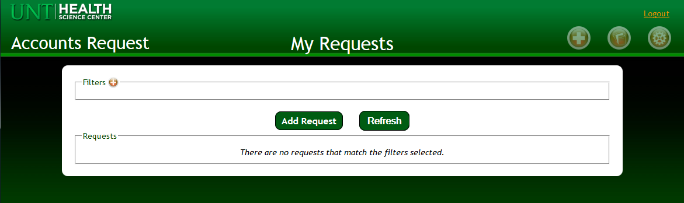

- Choose who you are making the request for, yourself or someone else.
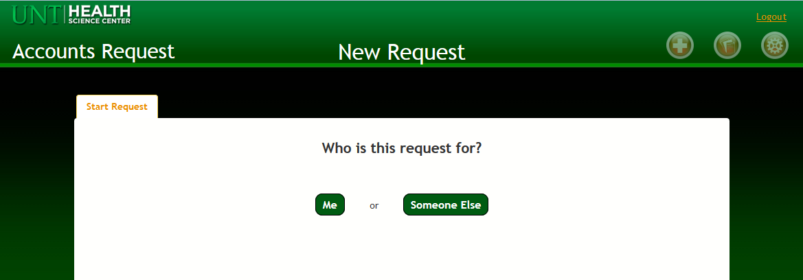

- When making a request for yourself, you may be prompted to take the annual security training. Please do so if prompted, as you must be compliant with security training in order to receive and continue to have access.
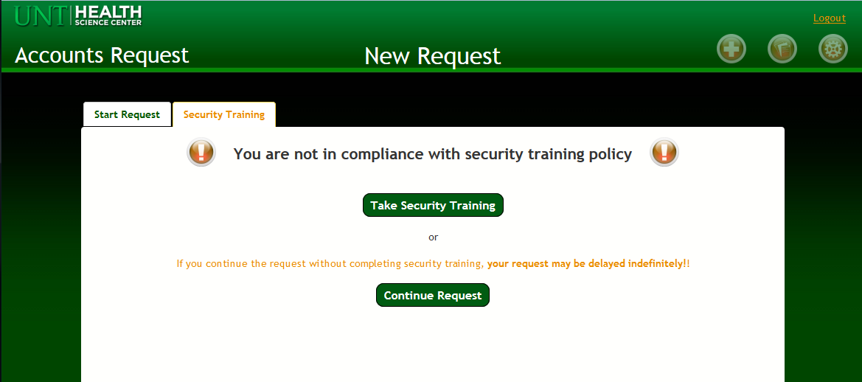

- If you are making the request for yourself, you will be asked to provide information, such as your name and supervisor’s email. Please choose the correct department, so that the department may approve the request.
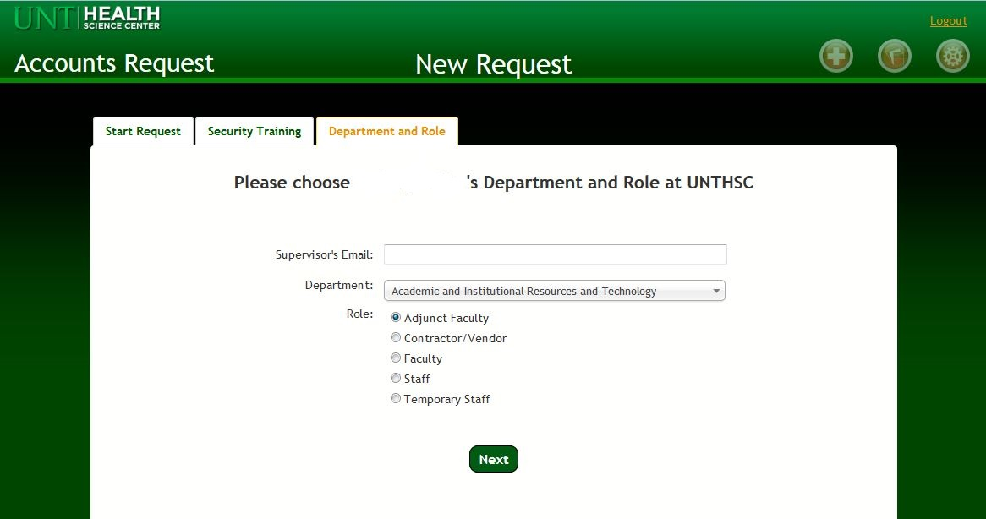

- Whether you are making a request for someone else, such as a contractor, student worker, or subordinate, you will be asked to either search by EUID or for new users with no EUID, to manually enter information. Please note, to process requests for users who do not have an EUID, such as contractors, the date of birth and last 5 digits of the Social Security Number are needed. To protect the user’s privacy, that data will not be collected. Please notify the user that they will be contacted for this info, and please provide accurate contact information.
******If a user has an EUID, it is highly preferable to use their EUID to submit a request. Requests made by EUID can be processed more quickly and accurately.

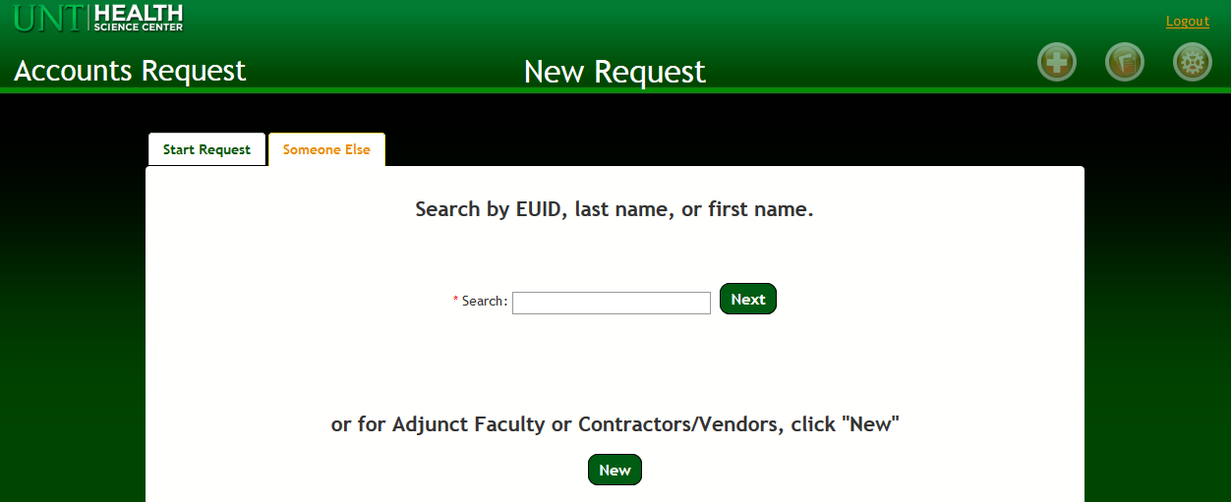

- Either way, you must enter the supervisor’s email and the role of the person who needs access.
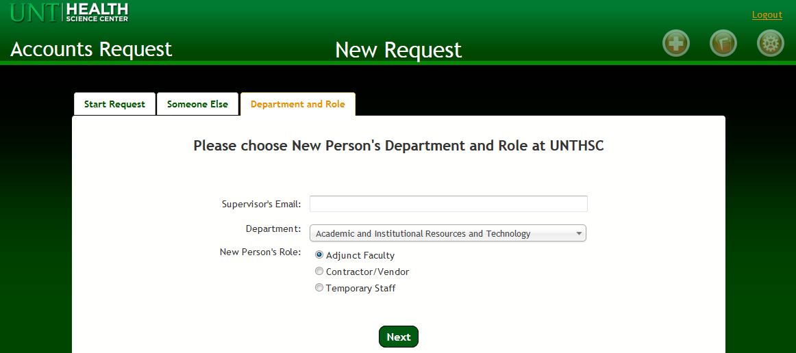

- Next, you will see a contact information screen. Requests for existing users will display the information in EIS. If the information is not correct, visit MyHSC and update the info. New users will not have any contact information yet - fill this screen out.
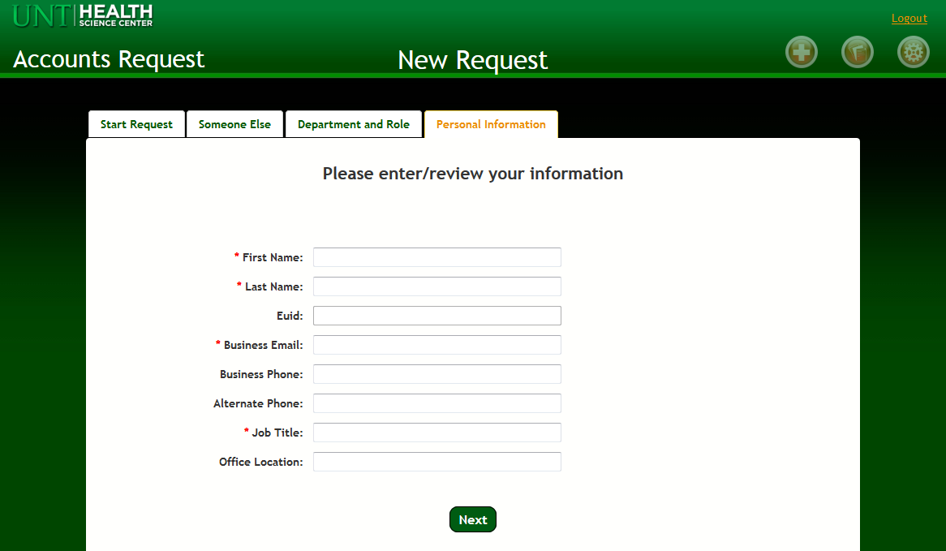

- Then, you will see the option to request access to secure resources, such as shared drives or applications. Choose what type of resource access is needed. Use the Special Instructions box to provide information, like what shared drive folders are needed.
  - If necessary, you can specify when resource access should end.
  - Non-paid workers, adjunct faculty, contractors, and vendors will automatically receive an account expiration date of 6 months, and must be renewed by the sponsoring department at that time.
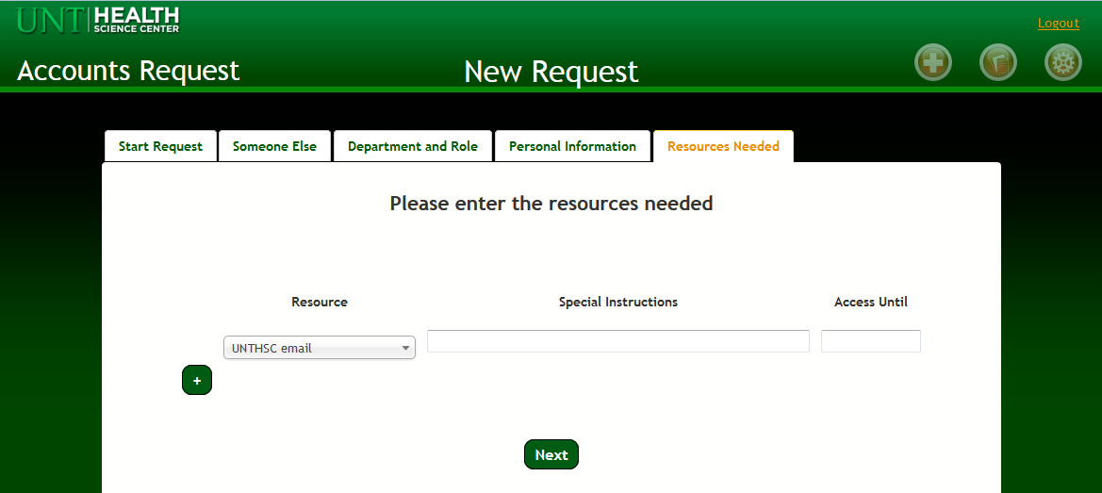

- Finally, you will be given the opportunity to review your request. If you need to make a change, use the tabs at the top of the page to navigate backwards. If it looks right, submit the request.
- You can go back to the home screen, where you will see your request. You will also see a general status.
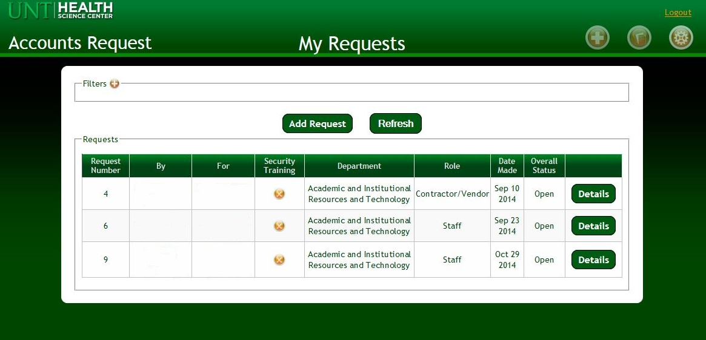
- The Details button holds additional information about the status. Some statuses you might see:
  - Awaiting Departmental Approval: the department must approve the request.
  - Awaiting Accounts Admin Approval: the Accounts Administrator must approve the request.
  - Awaiting Resource Owner Approval: the resource owner must approve the request before access is granted.
  - Awaiting Setup: the request is approved, but the access must be setup by the resource owner.
